Software Architecture and Design Document
IFQM Employee Ideation Tool (EIT)
Field | Detail
Document title | Software Architecture and Design Document
Product | IFQM Employee Ideation Tool (EIT)
Version | 1.1
Status | Reviewed and verified against the code - for final review
Date of issue | 15 August 2026
Prepared by | Development team
Reviewed by | (pending)
Approved by | (pending)
Classification | Internal - for IFQM and project stakeholders

Revision history
Version | Date | Author | Summary of change
1.0 | 02 August 2026 | Development team | First complete version. Covered all 25 requested deliverables and described the system as built.
1.1 | 15 August 2026 | Development team | Review pass. Section 10 rewritten with per-endpoint request, response, authentication and error detail. Section 13 restated as module structure rather than a class diagram, since the codebase has no classes. New section 26 covering work not yet done. Every diagram, count and traceability row checked against the code: endpoint, table, module, screen and test figures corrected, and the requirements matrix extended to cover subscriptions and billing, which the previous version listed as out of scope after it had been built.

How to read this document
This document describes how the IFQM Employee Ideation Tool is built. It is written for a mixed audience, so it avoids jargon wherever it can and explains it where it cannot. If you only need the shape of the system, sections 1 to 6 are enough. If you are going to work on it, read the whole thing.

The way it is organised
Part | What it covers | Who it is mainly for
A | Overview and requirements (sections 1-2) | Everybody
B | Architecture diagrams (sections 3-6) - what the system is made of and where each part runs | Anyone reviewing the design
C | Detailed design diagrams (sections 7-14) - how it behaves, step by step | Developers and testers
D | Running it (sections 15-23) - deployment, security, failure, monitoring, testing, release | Operations and QA
E | Decisions, traceability and outstanding work (sections 24-26) | Reviewers and auditors

Architecture diagrams and design diagrams
The two are kept apart deliberately, because they answer different questions. An architecture diagram shows the pieces and how they are arranged; it would still be true if nobody ever pressed a button. A design diagram shows what actually happens when somebody does. Mixing the two is the usual reason architecture documents become unreadable.
The separation is carried in the figure number itself, so it holds wherever a figure appears:
Prefix | Kind | Answers | Figures
A-n | Architecture - structure | What is the system made of, and where does each piece run? | A-1 to A-7
D-n | Detailed design - behaviour | What happens, step by step, when somebody does something? | D-1 to D-15

Part B holds the architecture set and Part C the design set. Three architecture figures (A-5 deployment, A-6 security, A-7 integrations) and one design figure (D-15 failure handling) appear later, in Part D, because each belongs beside the operational discussion that uses it - a deployment diagram is of little use eleven pages away from the environment table. The prefix still says which kind each one is, and the list of figures below names the kind and the part for every figure in the document.

Conventions used in the diagrams
- Every diagram is a drawing, generated from a script rather than placed by hand, so a diagram and the thing it describes are changed in one action.
- Colour carries meaning and is consistent across every figure: indigo for the system and the path through it, teal for stored data, amber for a decision, green for a wanted outcome, red for a refusal, slate for anything outside our control.
- Colour is never the only signal. Every diagram reads correctly in black and white, and each one carries a legend directly beneath it.
- A solid box is something that exists. A solid arrow is something that happens now.
- Anything marked optional works only if that organisation has configured it. The product runs without any of them.
- Where a number is quoted - tables, endpoints, modules, screens, tests - it was counted from the code for this version, not estimated.

Assumptions this document rests on
# | Assumption | If it turns out to be wrong
A1 | Customers are small and medium businesses, mostly manufacturing, of roughly 20 to 500 staff. | Scale figures in section 20 would need revisiting, though nothing structural changes.
A2 | Each customer wants their data kept physically separate from other customers. | The separate-database design could be simplified, but this is a common condition of sale.
A3 | Ideas are typed by people. There is no bulk import of ideas and no machine feed. | The submission path would need a different entry point.
A4 | Traffic is bursty and modest - busy at the start of a campaign, quiet between. | Sustained heavy traffic would need the caching described in section 20.
A5 | IFQM operates the platform and holds the customer relationship. | The platform console assumes exactly this separation.
A6 | Email and SMS are optional per customer. Many will run without either. | Nothing breaks; the features they power simply stay off.
A7 | Idea text is commercially sensitive to the customer. | The visibility rules in section 16 could be relaxed, and are already a setting.

What this document does not cover
- Taking payment. Plans, GST pricing, trials and holds are all built and are described in sections 2.1, 10.6.10 and 25. Connecting a payment gateway and issuing invoices is not, and is not designed here. See section 26.3.
- Commercial terms - what IFQM actually charges a given customer. The system records whichever figure the platform team sets.
- Single sign-on with the QCMS, DWM and Skills tools. Agreed in principle, blocked on an Azure tenant that does not exist yet. See ADR-011.
- The manual test case catalogue and the user guide, which are separate documents.
Section 26 lists everything that is not yet done, including the items above. It is deliberately the last section rather than a footnote, because it is the part of a handover most likely to be needed.

Contents
Word can generate a live table of contents with page numbers: place the cursor here and use References, then Table of Contents. The list below is the section order.
Contents
Part | No. | Section
Part A | Overview and requirements
 | 1 | System Overview and Objectives
 | 2 | Functional and Non-Functional Requirements
Part B | Architecture diagrams
 | 3 | Overall System Architecture
 | 4 | Architecture Description
 | 5 | Technology Stack
 | 6 | Module and Component Structure
Part C | Detailed design diagrams
 | 7 | System Workflow
 | 8 | Data Flow
 | 9 | Database Design
 | 10 | API Architecture and Specification
 | 11 | Use Cases
 | 12 | Sequence Diagrams
 | 13 | Module and Service Structure
 | 14 | User Interface and Screen Flow
Part D | Running the system
 | 15 | Deployment Architecture
 | 16 | Security Architecture
 | 17 | Integration Architecture
 | 18 | Error Handling and Exception Flow
 | 19 | Logging and Monitoring
 | 20 | Performance and Scalability
 | 21 | Backup and Disaster Recovery
 | 22 | Testing Strategy
 | 23 | Deployment and Release Plan
Part E | Decisions, traceability and outstanding work
 | 24 | Architecture Decision Records
 | 25 | Requirements Traceability Matrix
 | 26 | Work Not Yet Done

List of figures
Twenty-two figures. Architecture figures are numbered A-n and describe structure; design figures are numbered D-n and describe behaviour. The kind column is the same distinction, spelled out.
List of figures
Figure | Title | Kind | Part | Section
A-1 | System context | Architecture | B | 3.1
A-2 | Containers - what runs where | Architecture | B | 3.2
A-3 | Technology stack | Architecture | B | 5
A-4 | Modules and their dependencies | Architecture | B | 6
A-5 | Deployment | Architecture | D | 15
A-6 | Security layers | Architecture | D | 16
A-7 | Integrations | Architecture | D | 17
D-1 | Idea lifecycle | Design - workflow | C | 7
D-2 | Data flow, level 0 (context) | Design - data flow | C | 8
D-3 | Data flow, level 1 (inside the system) | Design - data flow | C | 8
D-4 | Registry tables and relationships | Design - entity relationship | C | 9.1
D-5 | Per-organisation tables and relationships | Design - entity relationship | C | 9.2
D-6 | Use case overview | Design - use case | C | 11
D-7 | Sign in with a password | Design - sequence | C | 12.1
D-8 | Submit an idea | Design - sequence | C | 12.2
D-9 | A decision, and what happens when nobody decides | Design - sequence | C | 12.3
D-10 | MSME registration and approval | Design - sequence | C | 12.4
D-11 | Push an approved idea to QCMS | Design - sequence | C | 12.5
D-12 | Module structure, taking the idea path as the example | Design - module | C | 13
D-13 | Screen flow | Design - UI flow | C | 14
D-14 | Wireframes of the main screens | Design - wireframe | C | 14
D-15 | How a failure is handled | Design - exception flow | D | 18

Every diagram type asked for is present: architecture (A-1, A-2, A-3), module (A-4, D-12), data flow (D-2, D-3), entity relationship (D-4, D-5), use case (D-6), sequence (D-7 to D-11), deployment (A-5), security (A-6), integration (A-7), and interface flow and wireframes (D-13, D-14). There is no class diagram, and section 13 explains why rather than leaving a reader to wonder.

List of tables
Most tables in this document run inside the prose they belong to. These are the ones worth finding on their own.
Table | Title | Section
2.1 | Functional requirements | 2.1
2.2 | Non-functional requirements | 2.2
6.1 | All 28 screens, grouped by who reaches them | 6.2
10.1 | Every route group, with its endpoint count | 10.5
13.1 | All 35 service modules | 13.2
25.1 | Requirements traceability - functional | 25
25.2 | Requirements traceability - non-functional | 25

PART A - OVERVIEW AND REQUIREMENTS

1. System Overview and Objectives

1.1 What the system is
The IFQM Employee Ideation Tool is a web application that lets the staff of a business put forward ideas for improving how that business works, and then makes sure those ideas are actually looked at, decided on and followed through.
Most businesses already have some version of this. It is usually a suggestion box on a wall, a messaging group, or a form somebody filled in once. They almost always stop working, and they stop for the same three reasons. Nobody hears back, so people give up after the second try. Everything lands on one person's desk unsorted, so nothing gets read properly. And when an improvement does happen, nothing connects it back to whoever suggested it, so the whole scheme feels like goodwill rather than a result.
This system is built to fix those three things specifically. Every idea has a status the person who submitted it can see. Every idea is scored and sent to whoever should actually decide. When an idea is implemented, the saving is recorded against it and the person who raised it is credited.

1.2 Objectives
# | Objective | How we would know it worked
O1 | Make it easy enough that shop-floor staff actually use it | Ideas arriving from people who are not office-based
O2 | Make sure no idea sits without an answer | Very few ideas past their review date
O3 | Send each idea to the right person automatically | Reviewers see only what is theirs to decide
O4 | Make the value visible | Savings recorded against implemented ideas, and reportable
O5 | Keep each customer's data completely separate | No path exists by which one customer can read another's data
O6 | Protect the idea itself until it has been reviewed | Full proposal text not readable by uninvolved colleagues
O7 | Be runnable by a business with no IT department | Setup is a working day, with no software to install
O8 | Work in the languages people actually speak | Seven languages, chosen per person

1.3 Scope
In scope: capturing ideas, scoring them, routing them for approval, tracking implementation and savings, rewarding contributors, reporting, running many customer organisations from one platform, handing approved ideas to the QCMS tool, and the subscription side of the platform - plans, free trials, and putting an organisation on hold when its period lapses.
Out of scope for this version: taking payment. The system records which plan an organisation is on, prices it including GST, runs the trial clock and holds the account when the period ends, but no payment gateway is connected and no invoice is issued - money changes hands outside the product and a member of the platform team marks the account paid. Also out of scope: single sign-on with other IFQM tools; a native mobile application, since the screens already work in a phone browser; and any automatic feed of ideas from another system.

1.4 Who uses it
Who | What they need from it | Roughly how many
Employee | Put forward an idea and see what happened to it | Most of the headcount
Reviewer or manager | See what is waiting on them, decide, give a reason | Perhaps one in eight
Organisation administrator | Run the scheme: people, rules, reports | One or two per business
IFQM platform administrator | Run the product across all customers | A handful, capped at five
MSME applicant | Apply for a workspace. Has no account yet | Occasional

2. Functional and Non-Functional Requirements
Each requirement has an identifier so it can be traced through to the module that implements it and the test that covers it. Section 25 does that mapping.

2.1 Functional requirements - what it has to do
Table 2.1 Functional requirements
ID | Requirement | Priority
FR-01 | A person signs in with an email address or phone number and a password. Five wrong attempts locks the account for fifteen minutes. | Must
FR-02 | A person can sign in instead with a one-time code sent to their phone. | Should
FR-03 | Somebody who forgets their password can reset it by email. | Must
FR-04 | Staff imported in bulk get a temporary password and must change it on first use. | Must
FR-05 | An employee submits an idea through a guided form covering the situation, the proposed fix, the business case, attachments and colleagues who helped. | Must
FR-06 | The form warns about similar ideas that already exist. | Should
FR-07 | An idea can be saved as a draft, visible only to its author. | Must
FR-08 | Every submitted idea is scored out of 100 automatically. | Must
FR-09 | Ideas are sent to a reviewer, either up the reporting line or to a committee. | Must
FR-10 | An idea with no answer inside the agreed time moves up to the next approver. | Must
FR-11 | A reviewer approves, rejects or passes an idea onward, with a reason. | Must
FR-12 | Anyone looking at an idea can see whose desk it is on. | Should
FR-13 | Approved ideas get an owner and a target date, and their saving is recorded. | Must
FR-14 | Contributors earn points; a leaderboard shows the top contributors. | Must
FR-15 | Employees can vote and comment on each other's ideas. | Should
FR-16 | Time-limited challenges can be run to ask for ideas on one problem. | Could
FR-17 | Browse screens show a one-line summary of a solution, never the full text. | Must
FR-18 | Each organisation decides who may read the full text. | Must
FR-19 | An administrator can archive old ideas without deleting them. | Should
FR-20 | An idea can be marked for patentability, separately from its approval. | Should
FR-21 | Ideas export to spreadsheet and PDF, honouring the filters on screen. | Must
FR-22 | Rejected ideas have their own screen so they can be read as a set. | Should
FR-23 | Staff can be added in bulk from a spreadsheet. | Must
FR-24 | The reporting structure can be corrected from a downloadable spreadsheet. | Should
FR-25 | The user list can be filtered by role, department, status or manager. | Should
FR-26 | A business can apply for a workspace itself, from a work email address. | Must
FR-27 | Free and disposable email domains are refused at application. | Must
FR-28 | No workspace is created until IFQM approves the application. | Must
FR-29 | IFQM can create, pause and remove organisations. | Must
FR-30 | IFQM sees counts and totals only, never idea content. | Must
FR-31 | Sign-in activity is recorded and viewable by IFQM. | Should
FR-32 | Approved ideas can be handed to the QCMS tool. | Should
FR-33 | Each organisation sets its own branding, categories and approval chain. | Must
FR-34 | The interface is available in seven languages. | Must
FR-35 | Support tickets can be raised by a customer and answered by IFQM. | Should
FR-36 | IFQM holds a catalogue of subscription plans, priced in whole paise with GST either included or added. | Must
FR-37 | The plan and the free-trial length are chosen by IFQM at the moment an application is approved, and either can be changed at any time afterwards. | Must
FR-38 | A new organisation gets a free trial, 14 days by default, adjustable per organisation. | Must
FR-39 | When a trial or paid period lapses the organisation is put on hold and cannot use the platform until IFQM records payment. | Must
FR-40 | IFQM sees one screen per organisation carrying its registration details, headcount, idea counts, implemented and pushed totals, and its billing state. | Should
FR-41 | The monthly request allowance follows the organisation's plan, and can never lock a workspace out of signing in or raising a ticket. | Should
FR-42 | An unknown web address shows a helpful page with working links rather than a browser error, and the public pages carry breadcrumbs, FAQs and page descriptions. | Could

2.2 Non-functional requirements - how well it has to do it
Table 2.2 Non-functional requirements
ID | Area | Requirement | How it is met
NFR-01 | Separation | One customer must never reach another's data | A separate database per organisation. The connection is chosen from the signed-in session, so reaching another would mean opening the wrong database on purpose
NFR-02 | Confidentiality | Idea text must not be readable by uninvolved colleagues | Browse lists never carry the full text. The detail screen filters by role and relationship. The rule is enforced by the server, not the screen
NFR-03 | Access control | Access ends at once when somebody is removed or demoted | The user is read back from the database on every request rather than trusted from the session token
NFR-04 | Passwords | Passwords must not be recoverable | Stored as bcrypt hashes. Resetting is the only route, by design
NFR-05 | Transport | Nothing sensitive travels in the clear | HTTPS enforced, plain HTTP redirected, HSTS sent, database connections use TLS
NFR-06 | Abuse | One machine or one customer cannot exhaust the platform | Rate limits per address, plus a request quota per organisation
NFR-07 | Performance | Screens should feel immediate at normal size | Indexed queries, pagination, and lists capped at 100 rows
NFR-08 | Scale | Must cope with several thousand staff in one organisation | Search, filtering and paging happen in the database. No screen loads a whole table
NFR-09 | Availability | A fault in a minor feature must not take the system down | Logging, notifications and usage counting fail quietly and the request continues
NFR-10 | Recoverability | Data must survive a mistake or a failure | Managed database with automatic backups and point-in-time recovery, plus a backup script for self-hosting
NFR-11 | Auditability | It must be possible to reconstruct what happened to an idea | An append-only history on every idea, and a separate sign-in record
NFR-12 | Usability | Runnable by a business with no IT staff | Everything is a screen in the app. 74 plain-English explanations sit beside the technical settings
NFR-13 | Accessibility | Usable by keyboard and readable on a phone | Visible focus outlines, keyboard-reachable controls, layouts that reflow
NFR-14 | Language | Seven Indian languages | All interface text is looked up by key. English carries 1,116 keys and each of the six other languages 822, so 294 strings fall back to English rather than breaking the screen. Partial - see section 26
NFR-15 | Portability | Not tied to one hosting company | Standard Node and MySQL. Which host is used is configuration, not code
NFR-16 | Maintainability | A new team must be able to take it over | Rules live in one layer. A technical manual records the non-obvious decisions and why they were made
NFR-17 | Privacy | Collect only what is needed | Aadhaar, bank details and full dates of birth are deliberately not collected
NFR-18 | Safe defaults | An insecure configuration must not start | The server refuses to boot with a weak signing key, a blank database password, or developer settings left in production

PART B - ARCHITECTURE DIAGRAMS
This part answers one question: what is the system made of, and where does each piece run. It does not describe behaviour - that is Part C. The two are kept apart on purpose, because mixing them is the usual reason architecture documents stop being readable.

3. Overall System Architecture

3.1 The system in its surroundings
The first diagram shows the system as a single box, with the people who use it and the outside services it talks to. It is the right place to start because it makes the boundary obvious: everything inside the box is ours to build and run, everything outside it is somebody else's.
Figure A-1 System context
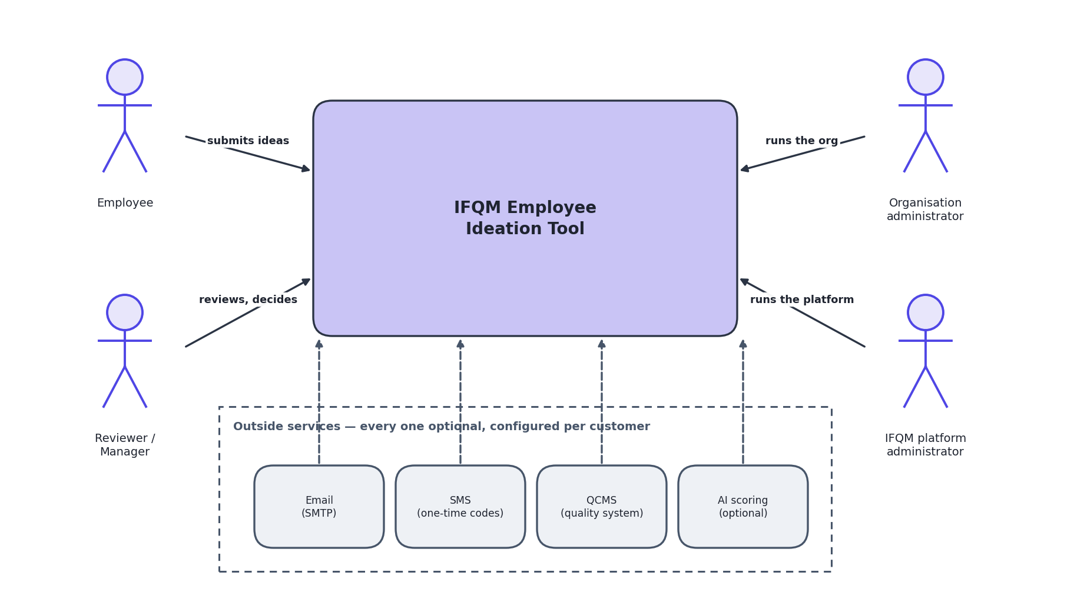
Legend: Boxes are systems. Arrows show who talks to whom. Dashed edges elsewhere in this document mean optional or not yet built.
Note the four outside services at the bottom. Every one of them is optional and is configured per customer. A customer can run the whole product with none of them connected, and many will.

3.2 The system opened up
The second diagram opens the box. There are three places where code or data lives: the visitor's browser, the application server, and the database.
Figure A-2 Containers - what runs where
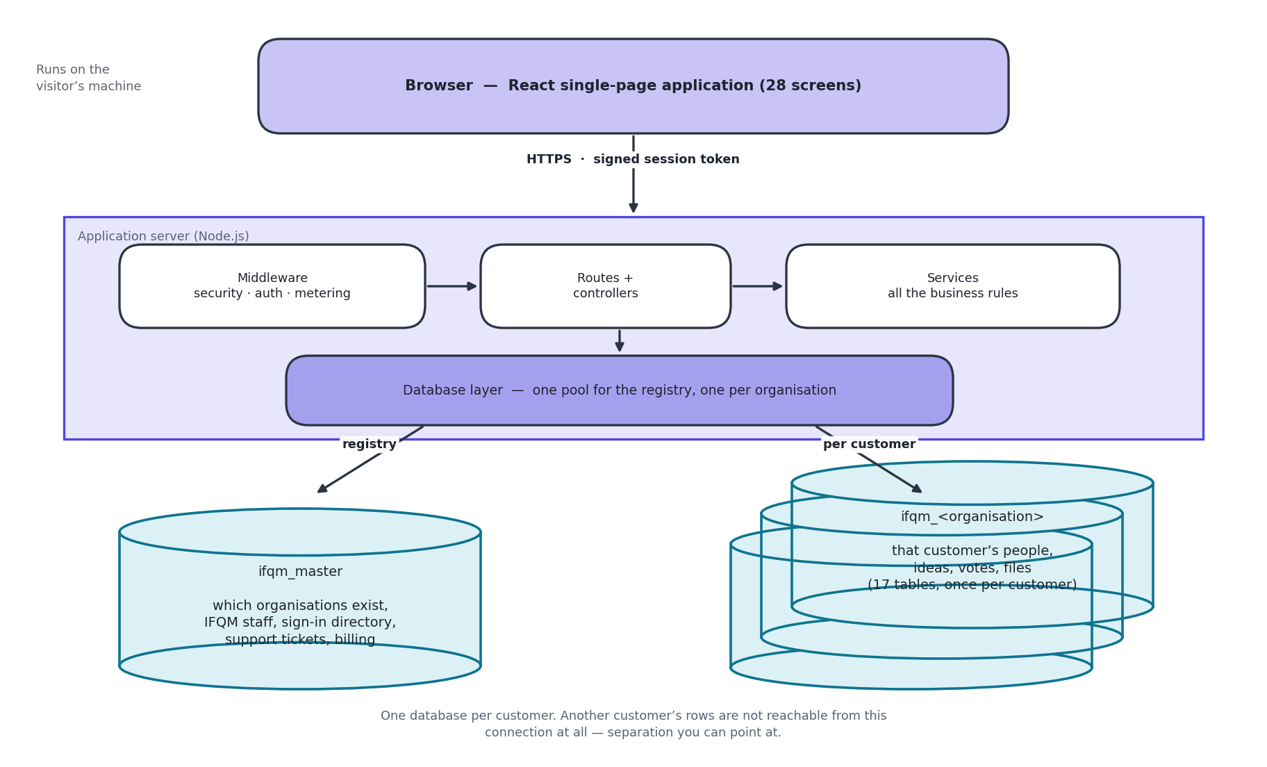
Legend: Vertical lines separate the three places code and data live. Every arrow is HTTPS or a database connection over TLS.
The single most important thing on this diagram is on the right: one database for the registry, and then a completely separate database for every customer organisation. That is what makes it impossible for one customer to see another's information.

3.3 Why it is built this way
Principle | What it means in practice | Why
One database per customer | Each organisation's people, ideas and files live in their own database. The registry only records which organisations exist and where each one lives. | Separation you can point at. A mistake in a query cannot leak across customers, because the wrong data is not in the connection at all.
Rules in one layer | All the business rules sit in the service layer. The web layer above only handles requests; the database layer below only fetches rows. | The rules can be tested directly, and a new way of reaching the system cannot accidentally bypass them.
Never trust the session alone | The signed-in user is read back from the database on every single request. | Removing someone, changing their role or resetting their password takes effect immediately rather than up to eight hours later.
Decide on the server | What a person may see is decided by the server. The screen is never the thing enforcing a rule. | A restriction that only exists in the screen is not a restriction. Anyone can read what was sent to their own browser.
Fail closed on setup, fail open on measurement | An unsafe configuration stops the server. A fault in logging or usage counting is written down and ignored. | Running insecurely is worse than not running. But a fault in counting should never become an outage for the customer.
Schema changes are deliberate | Deploying new code does not change the database. That is a separate, human step. | Automatic schema changes on deploy are how data gets lost.

4. Architecture Description
What each part is responsible for, and just as usefully, what it is not.

4.1 The screens
Component | Responsible for | Not responsible for
Single-page application | Drawing 28 screens, collecting input, showing results, holding the signed-in session in the browser, and switching language. | Deciding what anybody is allowed to see or do. It draws what it is given.
One API client file | Every call to the server goes through a single file, which attaches the session token and the organisation to each request. | Business rules. It is plumbing.

4.2 The server
Component | Responsible for | Not responsible for
Middleware chain | Security headers, allowed origins, rate limiting, identifying the user, choosing the organisation's database, and counting usage. Runs before everything else. | Anything specific to ideas, users or approvals.
Routes | Mapping a web address to a piece of code, and naming which roles may reach it. | Any rule beyond the role check.
Controllers | Reading the request, calling one service, sending the reply. | Business rules. A controller with an 'if' in it about ideas is a mistake.
Services | All the actual rules: what a valid idea is, who reviews it next, who may read the text, what a score means, when to award points. | Anything to do with HTTP. A service never sees the web request, which is why it can be tested on its own.
Database layer | Holding one connection pool for the registry and one per organisation, and handing back the right one. | Deciding who is allowed to use it.

4.3 The data
Component | Responsible for | Not responsible for
The registry | Which organisations exist, which database each uses, IFQM staff accounts, the sign-in directory, one-time codes, support tickets, sign-in history and usage counters. | Anything about an individual employee, or any idea. It is deliberately thin.
One database per organisation | That organisation's people, ideas, votes, comments, approval history, files and settings. 17 tables, repeated per customer. | Knowing that any other organisation exists.
Uploaded files | Attachments on disk, one folder per organisation, served only through a checked download. | Being reachable by a web address. There is no public link to a file.

5. Technology Stack
What the system is built from, and why each choice was made. Versions are the ones in the project files today.
Figure A-3 Technology stack
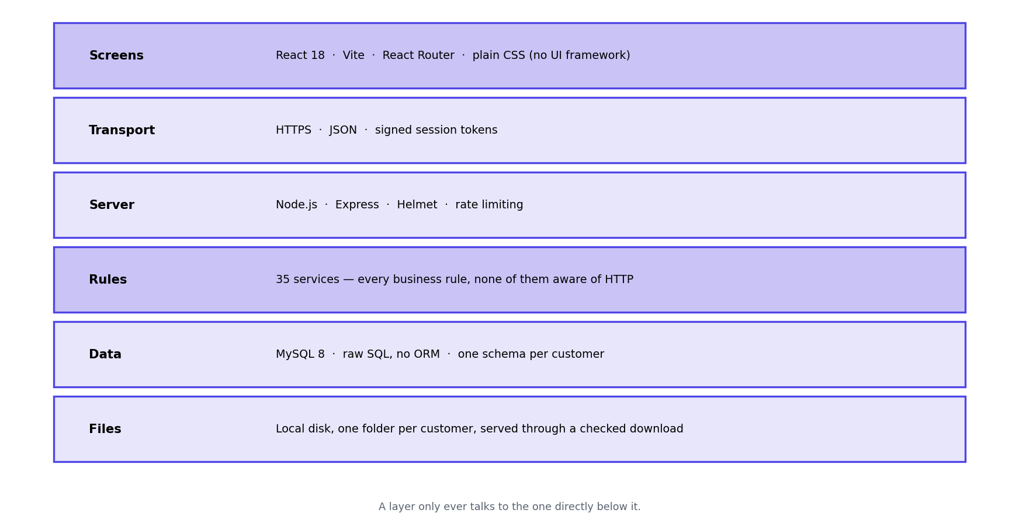
Legend: Each band is a layer. A layer only talks to the one directly below it.
Choice | Why this one
React with Vite | The screens are highly interactive - wizards, live filtering, overlays - which is what React is good at. Vite builds plain static files, so hosting the screens costs nothing and needs no server.
No UI framework | The design is a small set of CSS tokens and 18 shared components. A framework would have added a large dependency and a house style that would then need overriding everywhere.
Node.js with Express | The work is mostly waiting - on the database, on mail, on QCMS - which is exactly what Node is efficient at. Express is small enough that the whole request path can be read in one sitting.
MySQL | The data is strongly relational: people report to people, ideas belong to people, approvals reference both. It is also the database Indian hosting providers support best and the one most local administrators already know.
Raw SQL, no ORM | Multi-tenancy means picking a connection per request. An ORM would have added a layer between us and exactly the thing that matters most here, and hidden the queries that most need reviewing.
Signed tokens for sessions | The API holds no session state, so it can be restarted or run on two machines without logging anybody out. The security cost - a token that stays valid after a change - is removed by re-reading the user on every request.
Scoring built in by default | It works with no account, no API key and no cost, and no idea text leaves the system. An external provider is available but is off unless chosen.

6. Module and Component Structure
The server is organised in four layers plus a set of cross-cutting concerns. A request travels down the layers and the answer comes back up. No layer reaches past the one below it.
This section is the outside view - which layers exist and what belongs in each. Section 13 is the inside view of one of those layers: what a single module actually exports, what it keeps private, and which other modules it may call. The two are deliberately in different parts, because the first is a structural question and the second is a design one.
Figure A-4 Modules and their dependencies
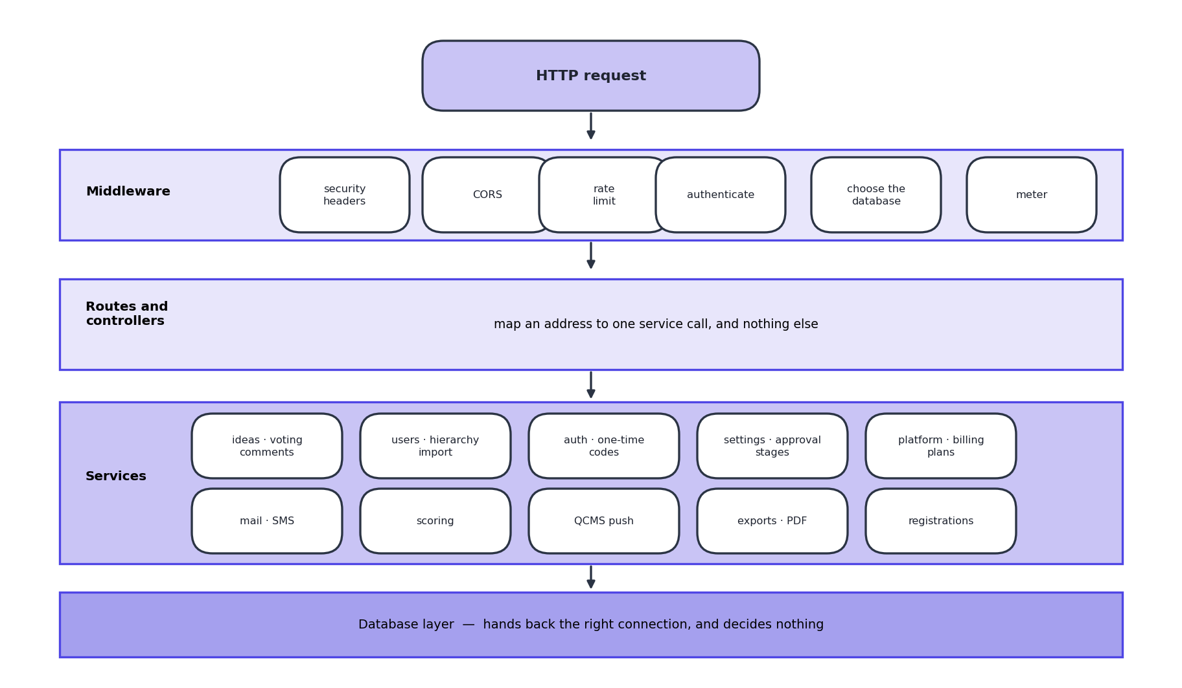
Legend: Top to bottom is the path of a request. A layer never reaches past the one below it; services never touch the web request directly.
There are 35 services. They are grouped here by what they are about rather than alphabetically, because that is how somebody looking for one would think about it. Section 13.2 names all 35.

6.1 The rule that keeps this honest
Every service takes a database connection as its first argument and never touches the web request. That one rule is what makes the services testable directly, and it is why a service cannot accidentally depend on who is calling it.
The clearest example is idea visibility. The rule about who may read a full proposal lives in one service function. The browse list, the detail screen and the idea board all call it. When the board was found to be bypassing it, the fix was to route it through the same function rather than to write the rule a second time.

6.2 Screens
Table 6.1 All 28 screens, grouped by who reaches them
Group | No. | Screens
Public | 3 | Landing page, sign in, apply for a workspace
Employee | 11 | Dashboard, my ideas, submit, challenges, all ideas, rejected ideas, idea board, leaderboard, profile, support, help
Reviewer | 1 | Review queue
Organisation admin | 4 | Admin panel (eight tabs: overview, ideas, users, hierarchy, categories, system, approved ideas, integration), analytics, audit trail, super admin
IFQM platform | 7 | Organisations, one organisation in detail, registrations, plans and billing, support tickets, sign-in activity, platform settings
Everywhere else | 2 | The forced password change screen, and the page shown for an address that does not exist

Alongside those sit 18 shared components that are not screens in their own right: the idea detail overlay, assign reviewers, review action, bulk import, bulk archive, the reporting-line lookup, the charts, the billing banner, breadcrumbs and the rest.

PART C - DETAILED DESIGN DIAGRAMS
Part B showed what the system is made of. This part shows what it does - the steps that happen when somebody presses a button, the shape of the data, and the screens themselves.

7. System Workflow
The life of an idea, from somebody having a thought to the saving being recorded. Everything else in the product exists to keep an idea moving along this path.
Figure D-1 Idea lifecycle
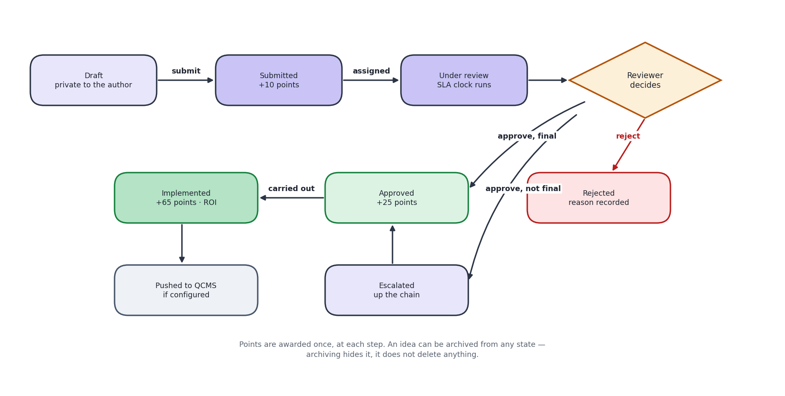
Legend: Rounded outcomes are the six states an idea can be in. Points are awarded once, at each step.
Points are awarded once at each step: 10 for submitting, 25 when approved, 65 when implemented. The larger number at the end is deliberate - it rewards ideas that were actually carried out, not ideas that merely sounded good.

7.1 The two ways an idea can be approved
 | One reviewer at a time | A committee together
How it moves | Up the reporting line, one manager at a time | Everyone assigned sees it at the same time
Who decides | Each person in turn passes it on or closes it | A set share must agree, for example 75 per cent
Best for | Everyday improvements with a clear owner | Ideas that cross departments, or need several opinions
If nobody answers | Moves up a level automatically after the escalation period | Same

7.2 Two things worth being clear about
- The review period and the escalation period are different. The first flags an idea as late so somebody chases it, and changes nothing. The second actually moves the idea to the next person. The escalation period should always be the longer of the two.
- Rejection is not a dead end. The reason is kept, and rejected ideas have their own screen, because the reason an idea was turned down is one of the most reusable things in the system.

8. Data Flow
Where information comes from, what is done with it, and where it ends up. Two levels: the whole system as one process, then the same thing opened up.
Figure D-2 Data flow, level 0 (context)
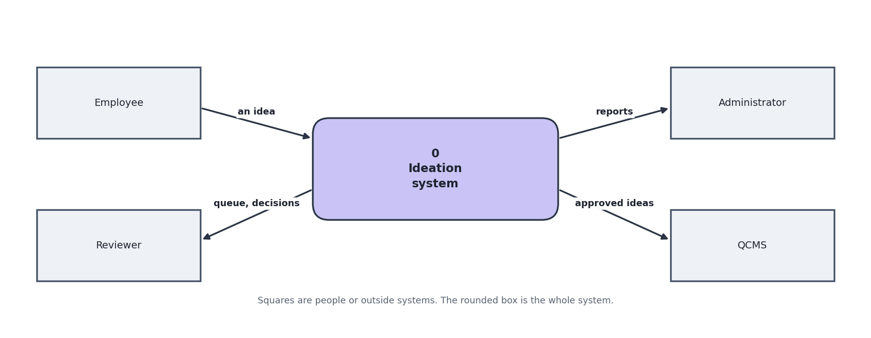
Legend: Squares are people or outside systems. The rounded box is the system. Arrows are data.
Figure D-3 Data flow, level 1 (inside the system)
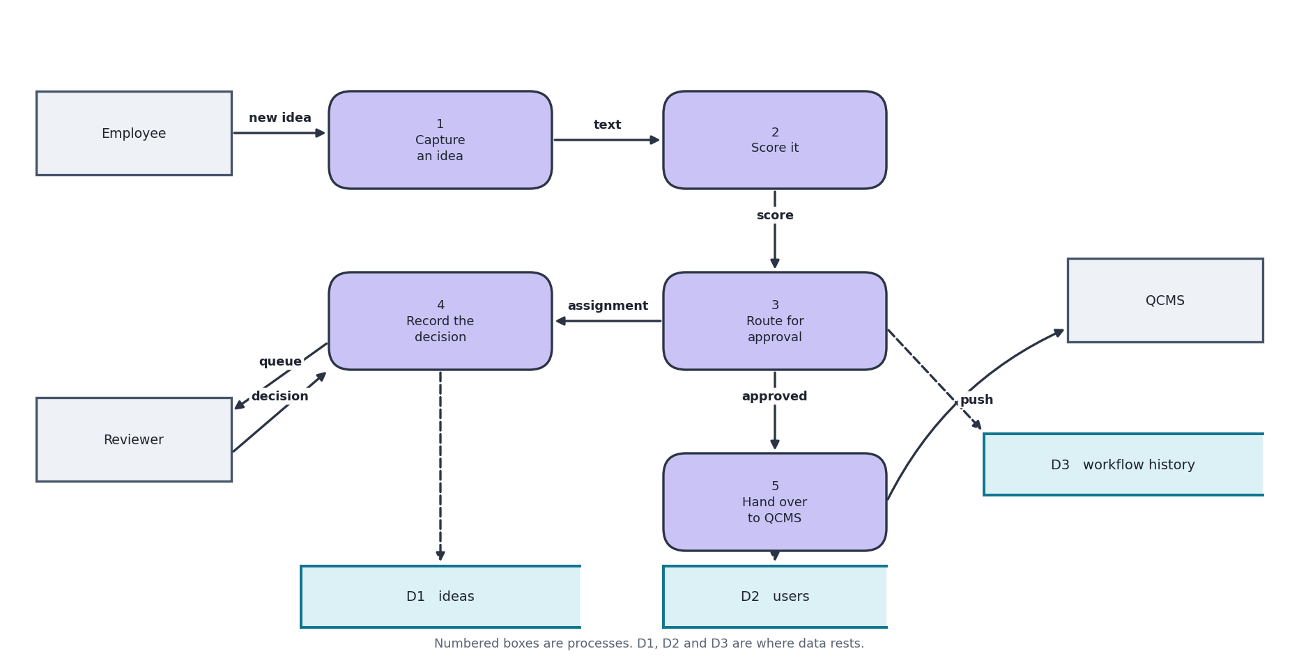
Legend: Numbered boxes are processes. D1, D2, D3 are stores of data. Arrows are named with what flows.
The two stores are worth noticing. D1 is shared by everybody and holds almost nothing about individuals. D2 exists once per customer and holds everything about their people and ideas. No process ever reads D2 for an organisation other than the one the signed-in user belongs to.

9. Database Design
There are two kinds of database. One registry, shared, holding as little as possible. Then one database per customer, holding everything about that customer.

9.1 The registry
Figure D-4 Registry tables and relationships
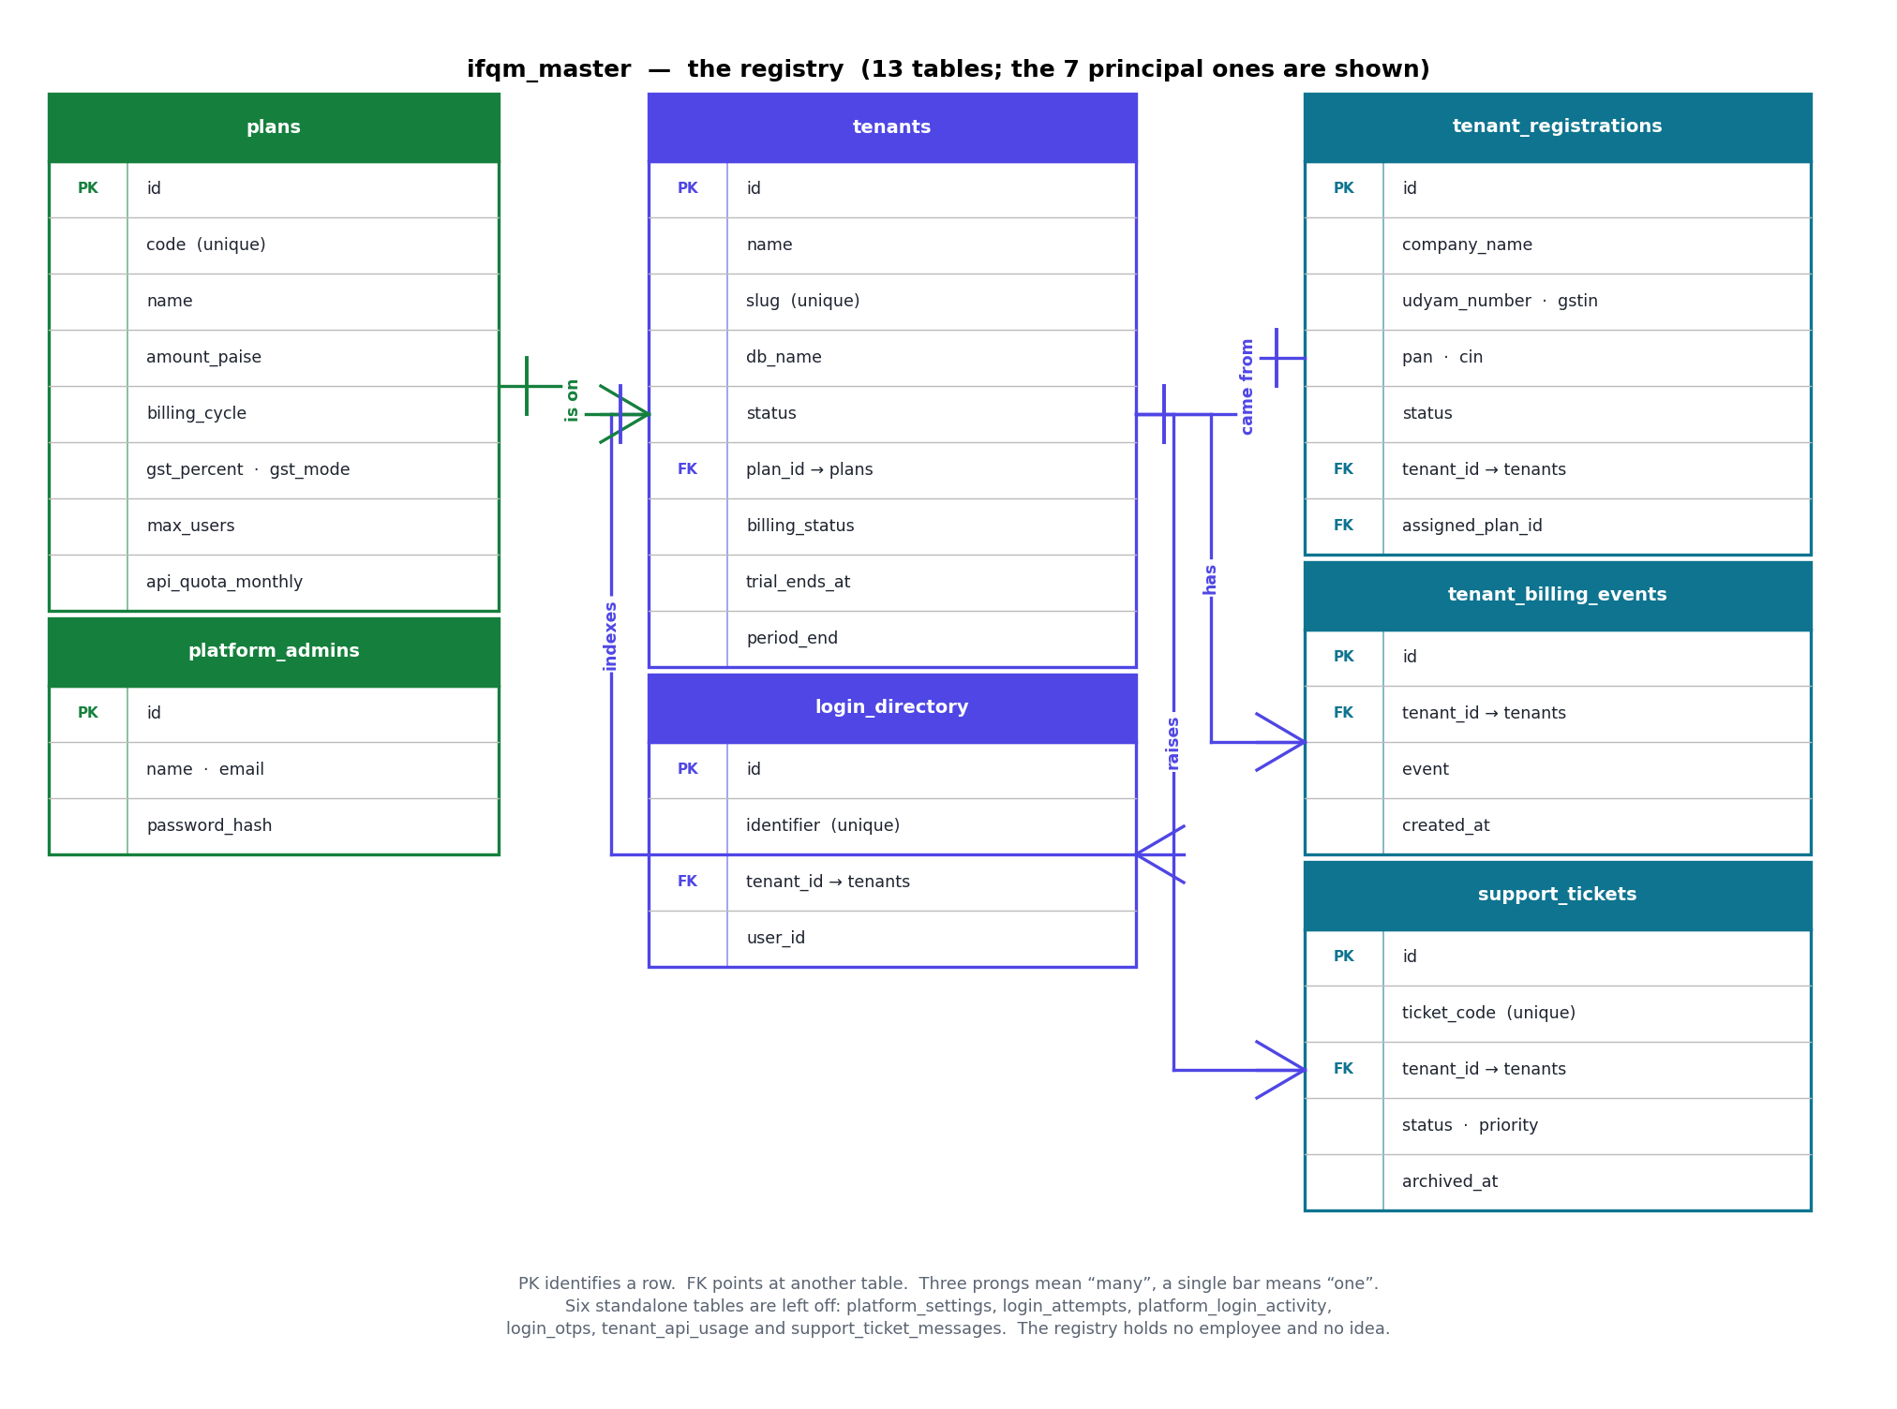
Legend: PK = the column that identifies a row. FK = a pointer to another table. Three prongs on a line mean 'many', a single bar means 'one'. 13 tables in the registry; the 7 principal ones are drawn.

9.2 One customer organisation
Figure D-5 Per-organisation tables and relationships
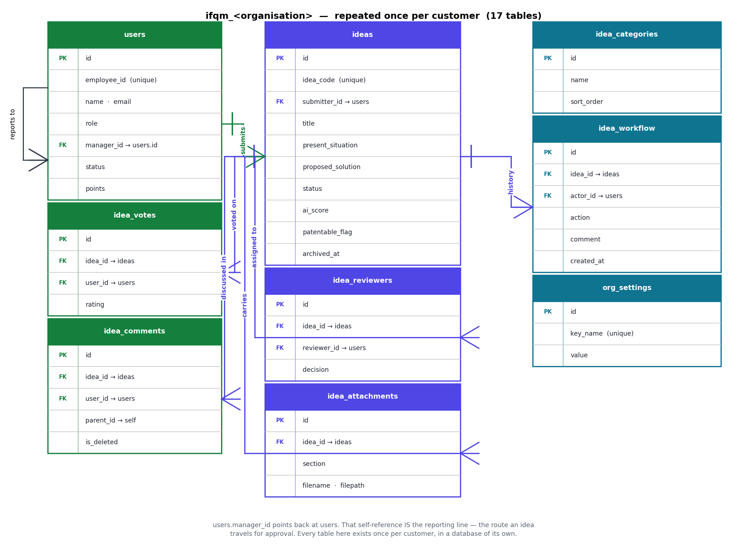
Legend: 17 tables per organisation, every one of them existing once per customer in a separate database. The 9 that carry the idea path are drawn; the remaining 8 (notifications, email_queue, password_reset_tokens, user_import_jobs, user_import_errors, idea_co_suggesters, idea_community_votes, challenges) hang off users or ideas without adding a relationship worth drawing.
The users table points at itself - that is the reporting line, and it is what ideas travel along when they escalate.

9.3 Design decisions in the data
Decision | Reason
Approval history is append-only | Every status change is written as a new row and nothing is ever edited. It is the audit trail, and an audit trail you can edit is not one.
Archiving is a date, not a delete | An archived idea keeps its points, its history and its recorded saving. It just leaves the working lists. Deleting would destroy exactly the evidence the scheme is measured on.
Patentability is its own column | An idea can be approved and not patentable, or turned down on cost and still worth filing. Folding it into the status would lose precisely those cases.
Both an estimate and a commitment for dates | One column is what the submitter guessed; another is what the owner committed to after approval. Keeping one column would lose the comparison.
Year of birth, not date of birth | The temporary first password uses only the year, so the day and month were personal data collected for nothing.
Settings are key and value rows | Each organisation has its own settings and new ones are added constantly. A column per setting would mean a schema change every time.
Tags stored as a short list in one column | The set of tags is fixed and small and is never queried relationally. A separate table would be ceremony with no benefit.

10. API Architecture and Specification
One HTTP interface, used by the screens and by nothing else at present. Everything lives under /api. There are 133 endpoints across 19 groups. Those figures, and the per-group counts in 10.5, are read out of the route files by a script rather than maintained by hand, because a hand-counted endpoint table is correct on the day it is typed and wrong a fortnight later.

10.1 Conventions
Aspect | Convention
Base path | /api. There is no version prefix - the only caller is the product's own screens, which are deployed together with the server. A version prefix would be added the day an outside party is given access.
Format | JSON in, JSON out, UTF-8. Uploads are multipart form data. Two endpoints answer with bytes rather than JSON: the attachment download and the idea PDF.
Success | An object with success set to true, plus named data. There is no generic "data" wrapper; the key says what it holds - ideas, user, subscription.
Failure | An object with success false and error set to one plain-English sentence, suitable for showing to a person unaltered. Some errors carry an extra field, such as retry_after on a lockout.
Authentication | A signed token in the Authorization header, as a Bearer token.
Organisation | Taken from the token, never from anything the caller can set freely. There is no tenant parameter on any endpoint.
Naming | Paths are lower case with hyphens; JSON fields are lower case with underscores, matching the column names they mostly come from.
Dates | Sent as strings. Timestamps are MySQL DATETIME in the server's zone; plain dates are YYYY-MM-DD. Anything that is not exactly YYYY-MM-DD is stored as empty rather than guessed at.
Paging | page and limit as query parameters where a list can grow. Lists are capped at 100 rows and the cap is applied by the server, not requested by the caller.
Idempotency | There are no idempotency keys. Where repeating a call would do harm - a second approval on one idea - the endpoint takes a named database lock and the repeat is refused with 409 rather than silently applied twice.

10.2 Authentication and authorisation
Every request carries the same header, and every guarded endpoint runs the same three checks in the same order. Nothing endpoint-specific happens before them.
Step | What is checked | Refusal
1 Token | Authorization: Bearer <token>. The signature and expiry are verified. | 401 with 'Not authenticated'
2 Freshness | The account is read back from the database and its password-change stamp compared with the one inside the token. | 401 - the session was opened before a password change, or the account is gone or deactivated
3 Role | The route names the roles allowed to reach it. Where the rule depends on the row rather than the role - your own idea, your report's idea - the service checks again after loading it. | 403 with 'Insufficient permissions'

Ten endpoints have no token check, and they are exactly the ones that cannot: the eight sign-in and password-reset calls under /auth, and the two under /registrations. Every other endpoint in the system is guarded. Of the ten, only the two registration endpoints are reachable by somebody who has no account at all, which is what makes them the pair worth watching.

10.3 Status codes
Code | Means | Typical cause
200 | Done | Everything, including creations - the API does not use 201
400 | The request is wrong | A required field is missing, a value is not in the allowed set, an organisation code is the wrong length
401 | Not signed in, or no longer signed in | No token, a tampered or expired token, a wrong password, a session opened before a password change
403 | Signed in, but not allowed | The role does not reach this route, or the row belongs to somebody else
404 | No such thing | An unknown id, or an unknown path - which answers 'Unknown action' rather than an HTML page
409 | Conflicts with the current state | The application was already approved, the organisation code is taken, the idea is being decided by somebody else right now
413 | Too large | The upload exceeds the organisation's own limit, or its storage allowance is full
429 | Too many | Rate limited by address, locked out after five wrong passwords, or over the plan's monthly request allowance
500 | A fault on our side | Always the generic sentence. The detail - table names, file paths, stack - goes to the log, never to the caller

10.4 Rate limits and quotas
Limit | Applies to | Allowance | On breach
Global | Each calling address | 300 requests per minute, configurable | 429 'Too many requests. Please slow down.'
Sign-in | Each calling address, on /auth | 30 attempts per 15 minutes, configurable | 429 'Too many authentication attempts.'
Heavy operations | Each calling address, on bulk import and similar | 10 per hour | 429
Account lockout | One account | 5 wrong passwords, then 15 minutes | 429 carrying retry_after in seconds
Plan allowance | One organisation | The monthly figure on its plan | 429 - but sign-in, support, notifications, branding, settings and the health checks are always let through, so an organisation over its allowance can still get in and raise a ticket

10.5 The endpoint map
All 19 groups. Counts are from the route files as they stand.
Table 10.1 Every route group, with its endpoint count
Group | No. | What it covers | Who may call it
/platform | 35 | Organisations and their detail, the registration queue, plans and billing, support tickets, platform settings, sign-in activity | IFQM platform staff only - a blanket guard on the whole group
/users | 18 | People, bulk import, the reporting line, the hierarchy template, role and department filters | Organisation admin, except the lookups every signed-in user needs
/ideas | 18 | Submit and draft, list, read, duplicate check, review actions, committee assignment, savings, implementation, archive, patentability | Signed-in, then narrowed per route: reviewer roles to decide, admin to archive
/auth | 10 | Sign in, sign out, one-time codes, password reset and change | Eight are open by necessity; change-password needs a session
/votes | 8 | Ratings, up and down votes, the idea board | Signed-in
/challenges | 5 | Time-limited campaigns | Signed-in to read, admin to run
/support | 5 | Tickets raised by a customer and their messages | Signed-in
/settings | 4 | One organisation's own settings, an email test, and its subscription | Reading is open to the organisation; writing is admin
/export | 4 | Ideas and leaderboard spreadsheets, analytics, single-idea PDF | Signed-in; analytics is restricted to senior roles
/branding | 4 | Logo and colours | Anyone reads, admin writes
/integrations | 4 | The QCMS key, the approved-ideas list, and the push | Organisation admin
/comments | 3 | Threaded comments on an idea | Signed-in
/categories | 3 | The organisation's own idea categories | Signed-in reads, admin writes
/upload | 3 | Attach a file, download one through a check, remove one | Signed-in
/registrations | 2 | A business applying for a workspace, and the live email check | Open. The only pair reachable without an account
/score | 2 | Re-score an idea, and explain a score | Signed-in
/notifications | 2 | The unread list, and marking them read | Signed-in
/reports | 2 | Analytics figures behind the charts | Signed-in, scoped by role
/leaderboard | 1 | The ranked contributor list | Signed-in

10.6 Endpoint specifications
Ten endpoints in full. They were chosen to cover every shape the API takes: an open call, a guarded write, a redacted read, a role-guarded state change, a file in, a file out, a provisioning call, an outbound integration, and a billing read.
10.6.1 POST /api/auth/login
Purpose | Exchange an email address or phone number and a password for a session.
Auth | None. This is the call that creates one.
Request | { "email": "priya@acme.co.in", "password": "...", "org_slug": "acme", "client_timezone": "Asia/Kolkata" }
Fields | email accepts an email address, a registered phone number, or an employee number. org_slug is optional - left out, the organisation is resolved from the sign-in directory. client_timezone is optional and is used only to describe roughly where a platform-admin sign-in came from.
200 | { "success": true, "user": { "id": 41, "name": "Priya S", "role": "employee", "points": 120, "must_change_password": false }, "token": "eyJ..." }
400 | "Email and password are required."
401 | "Invalid email/phone or password. 3 attempt(s) remaining."
429 | "Too many failed attempts. Please try again in 15 minute(s)." - plus retry_after in seconds
Notes | A wrong password, an unknown account and a deactivated account all answer the same way and take the same time, because a password check runs against a dummy hash even when nothing matched. Every attempt, successful or not, is written to the sign-in record.

10.6.2 POST /api/ideas/submit
Purpose | Submit an idea, or convert one of the author's own drafts into a submission. POST /api/ideas/draft is the same call with the same body and saves a draft instead.
Auth | Any signed-in user.
Request | { "title": "...", "present_situation": "...", "proposed_solution": "...", "impact_areas": "Quality,Cost", "impact_level": "High", "tangible_benefit": "...", "investment_required": "Under Rs 50,000", "feasibility": "High", "time_required": "3_6m", "solution_tags": ["quality","cost"], "co_suggester_ids": [12, 19, 24], "is_anonymous": false, "id": 142 }
Required | title, present_situation, proposed_solution. Everything else is optional - a half-formed idea is still worth capturing, and a reviewer can ask for the rest. id is present only when editing an existing draft.
Validated | feasibility must be Low, Medium or High; time_required one of three bands; solution_tags are filtered against a fixed set. An unrecognised value is stored as empty rather than creating a fourth band or a one-off tag that every filter would then miss. The author is dropped from their own co-suggester list, as are duplicates.
200 | { "success": true, "idea_id": 142, "idea_code": "EIT-0142", "ai_score": 78, "points_added": 10 }
400 | "Title, present situation and proposed solution are required."
Side effects | Scores the idea, sets the review due date from the organisation's SLA, routes it to the author's line manager, writes a workflow entry, awards 10 points, and queues an email. Points are awarded once: re-submitting an already-submitted idea returns points_added 0.
Notes | Two submissions in the same instant can collide on the generated idea code. The insert is retried with a fresh code rather than surfacing a 500 on a perfectly valid submission.

10.6.3 GET /api/ideas
Purpose | The list of ideas this person is allowed to see.
Auth | Any signed-in user. The scope is worked out from the role, not requested.
Query | search, status, impact, archived, tag, time_required - all optional
200 | { "success": true, "ideas": [ { "id": 142, "idea_code": "EIT-0142", "title": "...", "solution_summary": "First sentence only.", "solution_redacted": true, "ai_score": 78, "status": "Under Review", "submitter_name": "Priya S", "created_at": "2026-07-02 11:04:19" } ] }
Guaranteed absent | proposed_solution and present_situation are set to empty on every row of this response, for every caller including an administrator. The full text is only ever served by 10.6.4. Where the organisation has closed the solution section altogether, solution_summary is emptied too and solution_hidden_by_policy is set.
Scope | An employee sees their own ideas in full and everybody else's as title and status. A manager additionally sees their reports'. A plant head, executive or administrator sees all of them.
Notes | This endpoint used to select every column, so the whole text of every idea reached every employee's browser while the screen showed only a snippet. Truncating on screen is not privacy - see ADR-005.

10.6.4 GET /api/ideas/:id
Purpose | One idea, with as much of it as this reader is entitled to.
Auth | Any signed-in user. Entitlement is decided per row.
200 | { "success": true, "idea": { "id": 142, ..., "proposed_solution": "...", "solution_redacted": false, "viewer_inside": true, "workflow": [ ... ], "attachments": [ ... ], "comments": [ ... ] } }
Redaction | The author, the co-suggesters and anybody in the approval chain always read the full text - viewer_inside is true. For everybody else the organisation's own setting decides: the full text, a preview of a set length, or nothing. solution_redacted says which happened, so the screen can explain rather than appear broken.
403 | "Insufficient permissions." - the idea belongs to another part of the organisation this reader has no line to
404 | "Not found." - and the same answer for an id in another organisation, which is unreachable from this connection in any case

10.6.5 POST /api/ideas/review-action
Purpose | Approve, reject or pass an idea onward, with a reason.
Auth | Reviewer roles: team lead, project lead, manager, department manager, senior manager, plant head, executive, admin, super admin. The service then checks that this particular reviewer is the one the idea is waiting on.
Request | { "idea_id": 142, "decision": "approve", "comment": "Costed and worth doing." }
200 (passed on) | { "success": true, "decision": "Escalated", "escalated_to": "R Kulkarni", "points_awarded": 0 }
200 (final) | { "success": true, "decision": "Approved", "points_awarded": 25 }
403 | This person is not the reviewer this idea is waiting on
409 | "This idea is being updated by someone else. Please try again."
Concurrency | The whole decision is taken under a named database lock keyed on the idea. A double-tapped Approve button used to read 'no recent action' twice and write two, so an idea could be approved five times with five audit entries. The lock lives in MySQL rather than in the process, so it holds across two servers.
Side effects | Appends to the idea's history, awards points, notifies the next reviewer or the author, and queues an email.

10.6.6 POST /api/upload
Purpose | Attach a file to one section of an idea.
Auth | Any signed-in user, who must own the idea being attached to.
Request | multipart/form-data with file, idea_id and section. section is one of situation, solution, benefits, support.
200 | { "success": true, "filename": "EIT-0142-1722512345-plan.pdf" }
Accepted | pdf, png, jpg, jpeg, gif, xlsx, xls, csv, docx, doc
400 | "File type not allowed.", "No file uploaded.", or "File exceeds this organisation's 5 MB limit."
403 | "Unauthorized or idea not found."
413 | The organisation's total storage allowance would be exceeded
Notes | The size limit is the organisation's own setting, not a fixed 10 MB. No public URL is returned and none exists - the file is only reachable through 10.6.7.

10.6.7 GET /api/upload/:id/download
Purpose | Fetch an attachment, after checking that this reader may have it.
Auth | Any signed-in user. The attachment must belong to an idea in this organisation that this reader may see.
200 | The file itself, as bytes. Not JSON.
Headers sent | Content-Disposition: attachment - never inline, so an uploaded file cannot execute in the application's own origin. Plus X-Content-Type-Options: nosniff, a sandboxing Content-Security-Policy, and Cache-Control: private, no-store so it stays out of shared caches.
403 | "This attachment is not available." or "Invalid attachment path."
404 | "Attachment not found." or "File missing on disk." - the second is what a lost file on the current hosting looks like; see section 21.2

10.6.8 POST /api/platform/registrations/:id/approve
Purpose | Approve an MSME application, which provisions their workspace.
Auth | IFQM platform staff only.
Request | { "slug": "acme", "plan_id": 3, "trial_days": 14, "billing_note": "Rate agreed with the regional office." }
Fields | slug is the organisation code and defaults to the one proposed on the application. plan_id and trial_days are chosen by the approver, who has the company's headcount and turnover in front of them at that moment. Left out, trial_days falls back to the platform default of 14.
What it does | Creates the database, builds all 17 tables, creates the first administrator, registers the organisation, assigns the plan and starts the trial clock - as one sequence.
200 | { "success": true, "tenant_id": 12, "slug": "acme", "admin_email": "ops@acme.co.in", "temp_password": "..." }
400 | "Organisation code must be 2-30 characters."
409 | "This application has already been approved." or "Organisation code \"acme\" is taken. Approve with a different code."
Notes | The temporary password is returned exactly once and is never retrievable again - it is not stored in readable form anywhere. The operator relays it out of band and the new administrator must change it at first sign-in.

10.6.9 POST /api/integrations/push
Purpose | Hand approved ideas to the QCMS quality system.
Auth | Organisation admin.
Request | { "idea_ids": [142, 155], "only_pending": true }
200 | { "success": true, "attempted": 2, "imported": 1, "duplicate": 1, "failed": 0, "results": [ { "id": 142, "idea_code": "EIT-0142", "status": "imported", "message": "..." } ] }
400 | "QCMS integration is turned off. Enable it and save your API key first." or "No QCMS API key saved."
Partial success | The call answers 200 even when some ideas failed. Each idea carries its own status, because refusing the whole batch over one bad row would mean redoing the ones that worked.
Duplicates | A duplicate is counted as success, not failure. The idea has arrived; retrying would create a second copy in the customer's quality system.

10.6.10 GET /api/settings/subscription
Purpose | Where this organisation's account stands, and how long is left. This is what the banner across the top of the screen reads.
Auth | Any signed-in user of the organisation. It carries no other organisation's figures and no price the caller is not already paying.
200 | { "success": true, "subscription": { "billing_status": "trial", "state": "trial", "days_left": 6, "blocked": false, "trial_ends_at": "2026-08-16", "label": "Trial - 6 day(s) left" }, "plan": { "code": "STARTER", "name": "Starter", "amount_paise": 250000, "billing_cycle": "monthly", "gst_percent": 18, "gst_mode": "included", "max_users": 100 }, "quota": { "monthly": 60000, "used_month": 4120, "percent": 7, "source": "plan", "enforced": true } }
Money | Always whole paise, never rupees as a decimal. Rounding errors on money are the kind of bug that gets found by a customer.
blocked | True once a trial or paid period has lapsed. The screens read this to put the workspace on hold. An organisation with no end date on file is never blocked - locking somebody out because a field was left empty is the wrong way round.

11. Use Cases
Who can do what. The important line on this diagram is the one around the IFQM platform administrator: they sit outside the organisation and can never reach idea content, however senior they are.
Figure D-6 Use case overview
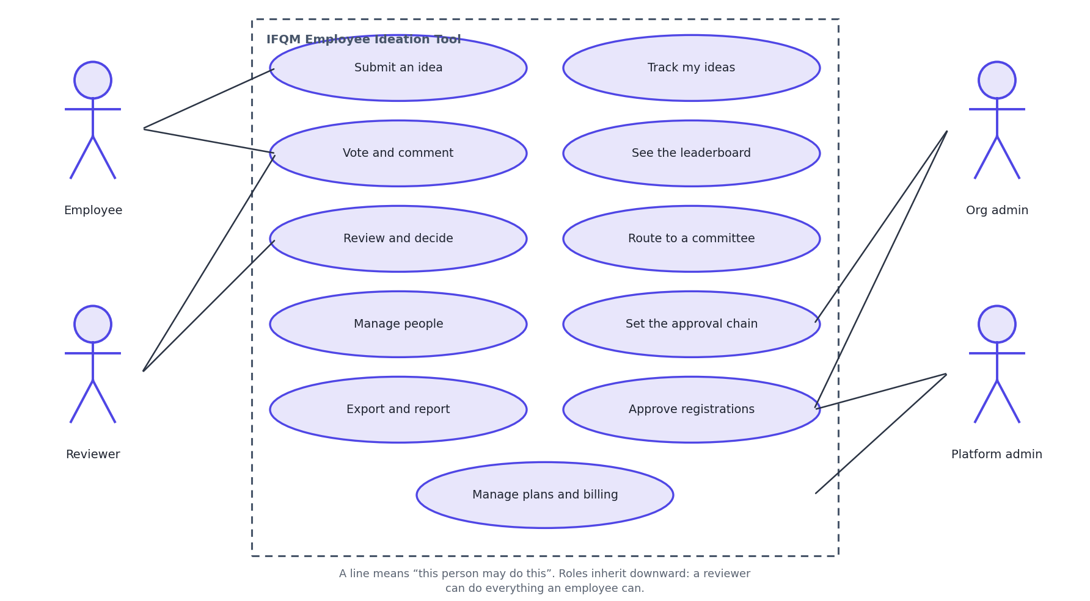
Legend: Stick-figure equivalents are on the left. Round brackets are things the system does.

12. Sequence Diagrams
Five journeys, chosen because each one shows something that is not obvious from the structure alone.

12.1 Signing in
Figure D-7 Sign in with a password
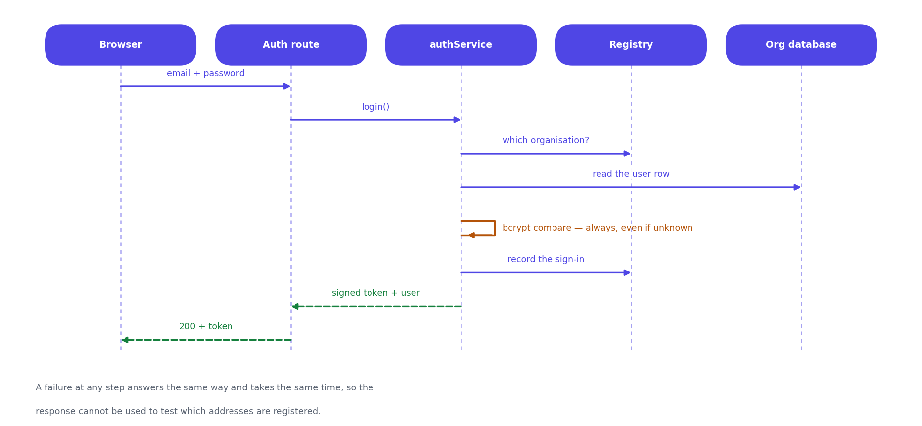
Legend: Each column is a participant and time runs downward. A solid arrow is a call, a dashed arrow is the answer to it, and a box across a column is that participant doing work. The database read on the far right is the per-request re-check that makes a removal or a demotion take effect immediately.

12.2 Submitting an idea
Figure D-8 Submit an idea
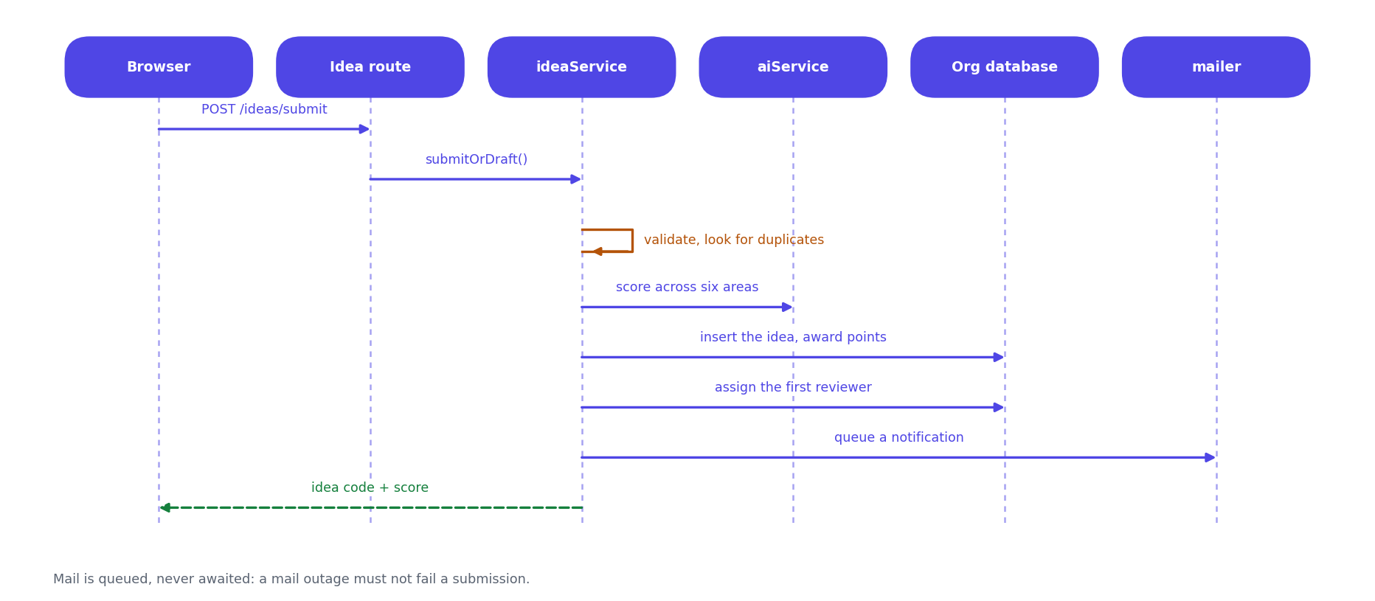
Legend: Each column is a participant and time runs downward. A solid arrow is a call, a dashed arrow is the answer to it, and a box across a column is that participant doing work. Scoring, the workflow entry, the points award and the email all happen before the submitter is answered, except the email, which is queued.

12.3 Reviewing and escalating
Figure D-9 A decision, and what happens when nobody decides
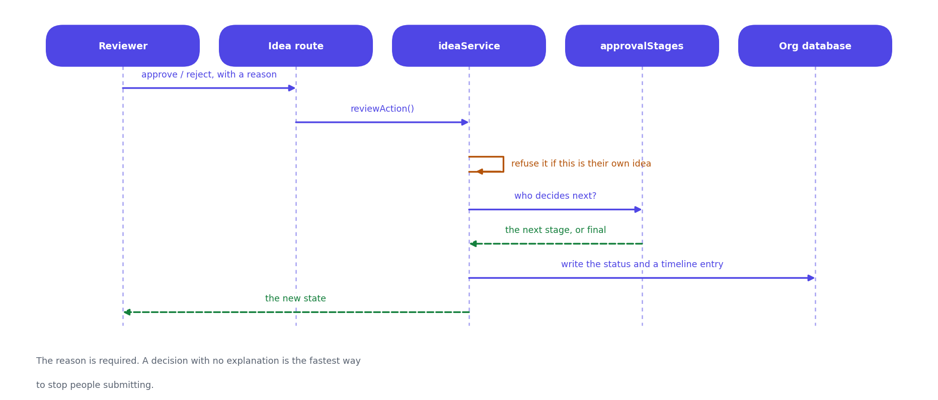
Legend: Each column is a participant and time runs downward. A solid arrow is a call, a dashed arrow is the answer to it, and a box across a column is that participant doing work. The whole decision runs inside a named database lock, so two clicks in the same instant cannot both be recorded.

12.4 A business applying for a workspace
Figure D-10 MSME registration and approval
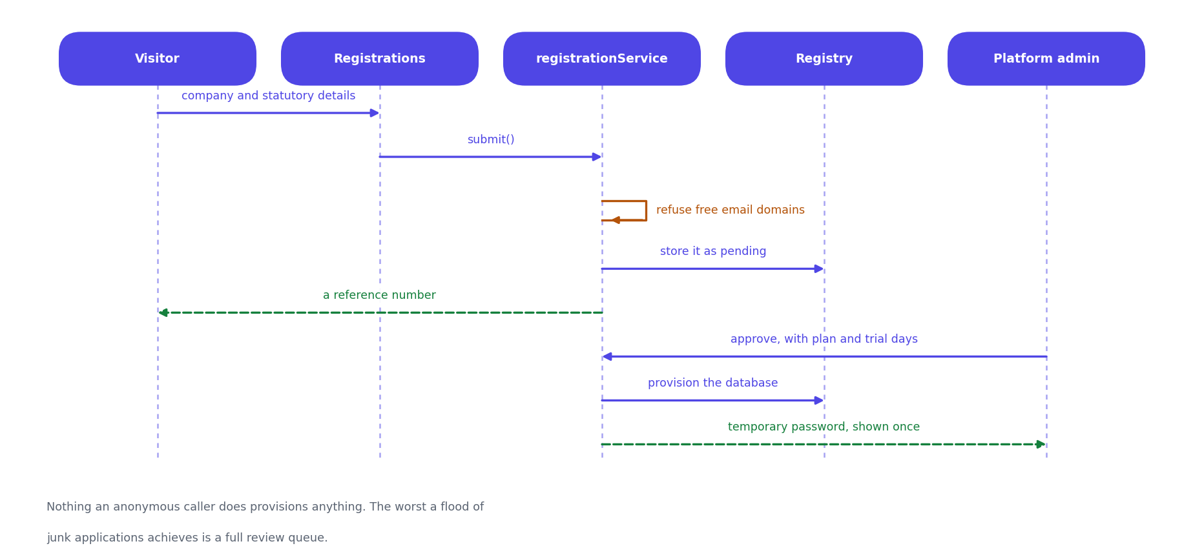
Legend: Each column is a participant and time runs downward. A solid arrow is a call, a dashed arrow is the answer to it, and a box across a column is that participant doing work. Nothing on the left half of this diagram creates anything. The database is not built until a human on the right approves.

12.5 Handing an idea to QCMS
Figure D-11 Push an approved idea to QCMS
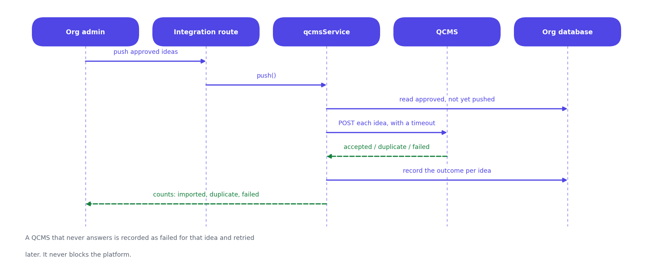
Legend: Each column is a participant and time runs downward. A solid arrow is a call, a dashed arrow is the answer to it, and a box across a column is that participant doing work. A duplicate answer from QCMS is recorded as success, not failure - the idea has arrived, and retrying would create a second copy.

13. Module and Service Structure
There is no class diagram in this document, and this section explains why rather than leaving a reader to notice the absence.
The server is not written in classes. It is written as ES modules that export plain functions - 35 service modules, none of which declares a class, holds instance state or takes part in an inheritance hierarchy. Drawing boxes labelled IdeaService with a compartment of methods would describe a design nobody wrote, and would suggest objects being constructed and held that do not exist anywhere in the codebase.
So the unit of structure here is the module, and that is what is drawn: each module, the functions it exports, the ones it keeps to itself, and which modules it is allowed to call. The notation is the familiar one - a plus sign is exported and callable from elsewhere, a minus sign is private to the file - because it is the meaning people already have for those symbols, not because a class is implied.
Figure D-12 Module structure, taking the idea path as the example
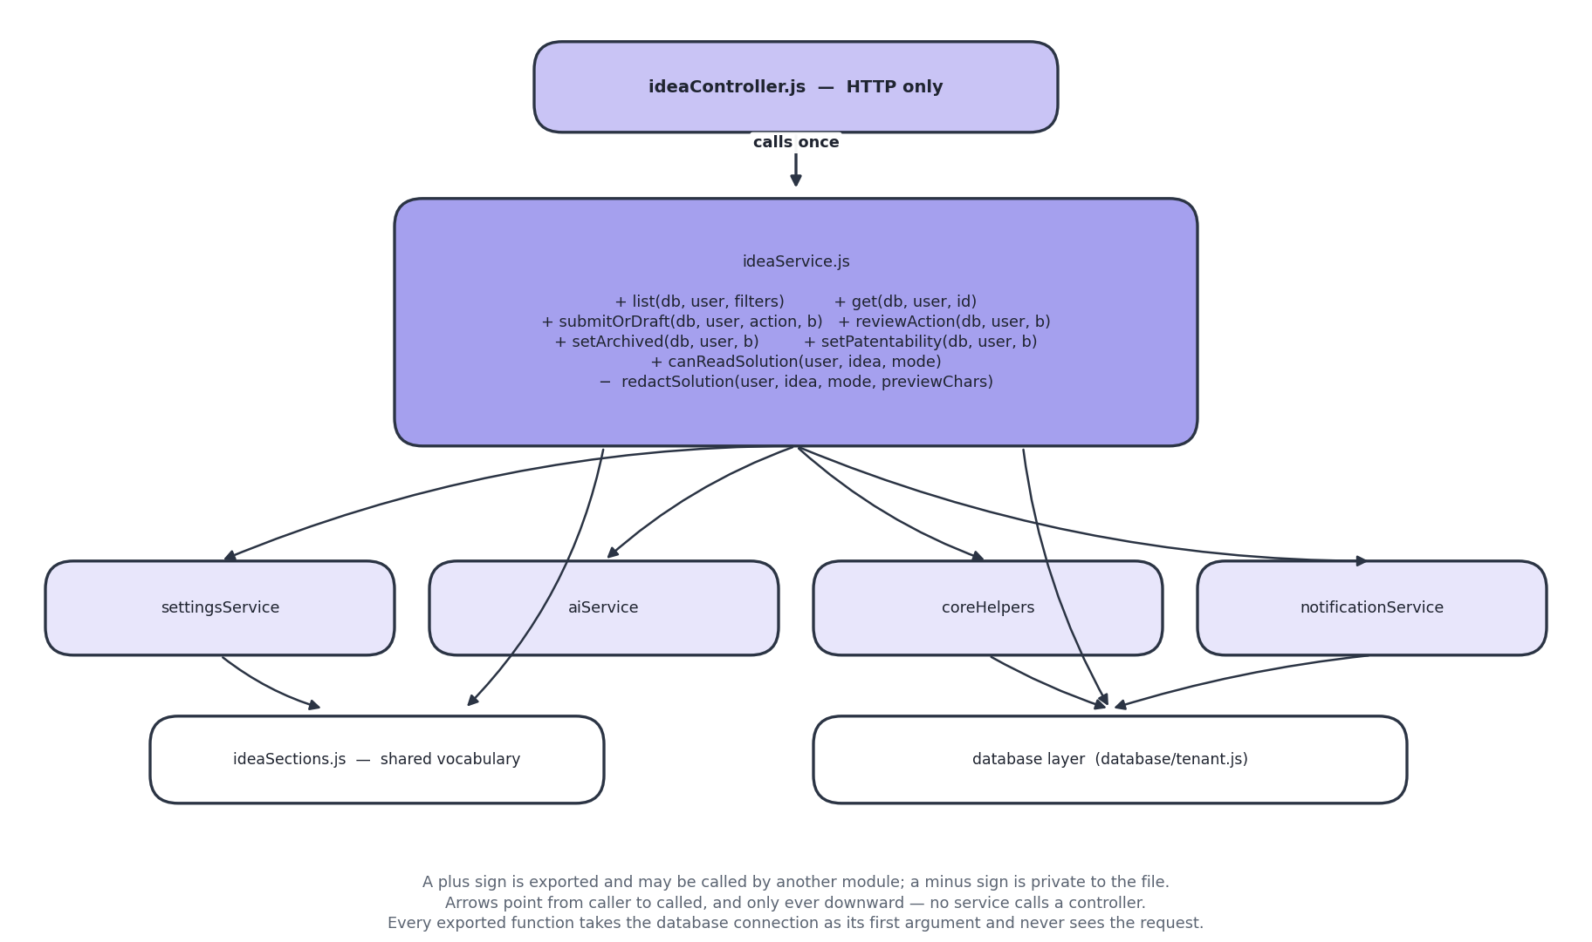
Legend: Boxes are modules, not classes - there are no classes in this codebase. A plus sign is an exported function; a minus sign is private to the file. Arrows point from caller to called and only ever travel downward.
One path through the system, drawn in full. There are 35 service modules; every one of them follows this same shape - a controller above it that only handles HTTP, the database connection passed in as the first argument, and calls that only ever travel downward.

13.1 What holds the structure together
Rule | What it means | Why it matters
A service never sees the request | Every exported function takes the database connection first and plain values after. There is no req, res or session object inside the services folder. | The rules can be called directly from a test, and a service cannot come to depend on who is calling it or how.
Calls only go downward | Controllers call services; services call other services, helpers and the database layer. No service calls a controller. | The dependency graph has no cycles, so any module can be read on its own.
Shared vocabulary lives in its own module | ideaSections.js holds the list of idea section names and the rule for which of them an employee may see. It imports nothing. | Without it, settingsService and ideaService would each need the other, which is a circular import - the concrete reason that module exists.
The role check happens twice | The route names the roles that may reach it; the service checks again once it has loaded the row. | The route check cannot know whether this idea is yours. Only the service, holding the row, can decide that.

13.2 The modules, grouped by what they are about
Table 13.1 All 35 service modules
Group | Modules
Ideas | ideaService, ideaSections, ideaPdfService, votingService, commentService, challengeService, categoryService, approvalStages
People | userService, userImportService, hierarchyTemplateService, directoryService, leaderboardService
Access | authService, otpService, smsService, hashPool
Organisation | settingsService, brandingService, notificationService, supportService, activityService
Platform | platformService, platformSettingsService, registrationService, planService, subscriptionService
Outward | qcmsService, integrationService, mailerService, aiService
Output | exportService, reportService, uploadService
Shared | coreHelpers

14. User Interface and Screen Flow
How somebody moves through the product, and roughly what the main screens look like. These are layouts, not final visuals.
Figure D-13 Screen flow
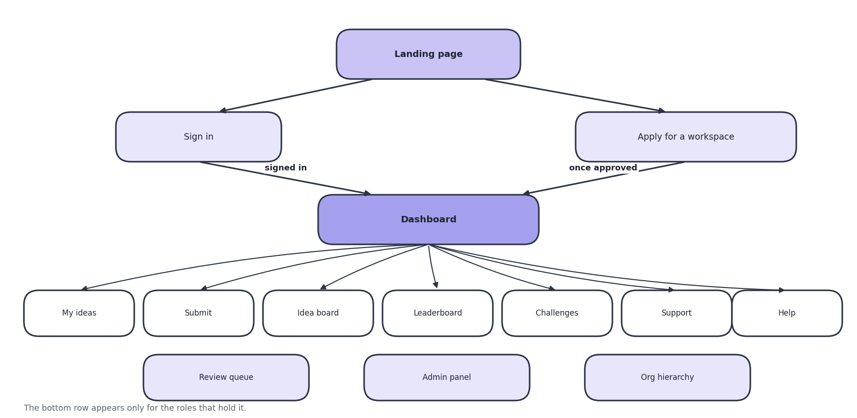
Legend: Boxes are screens. The path from the landing page to a signed-in screen is the same for everybody.
Figure D-14 Wireframes of the main screens
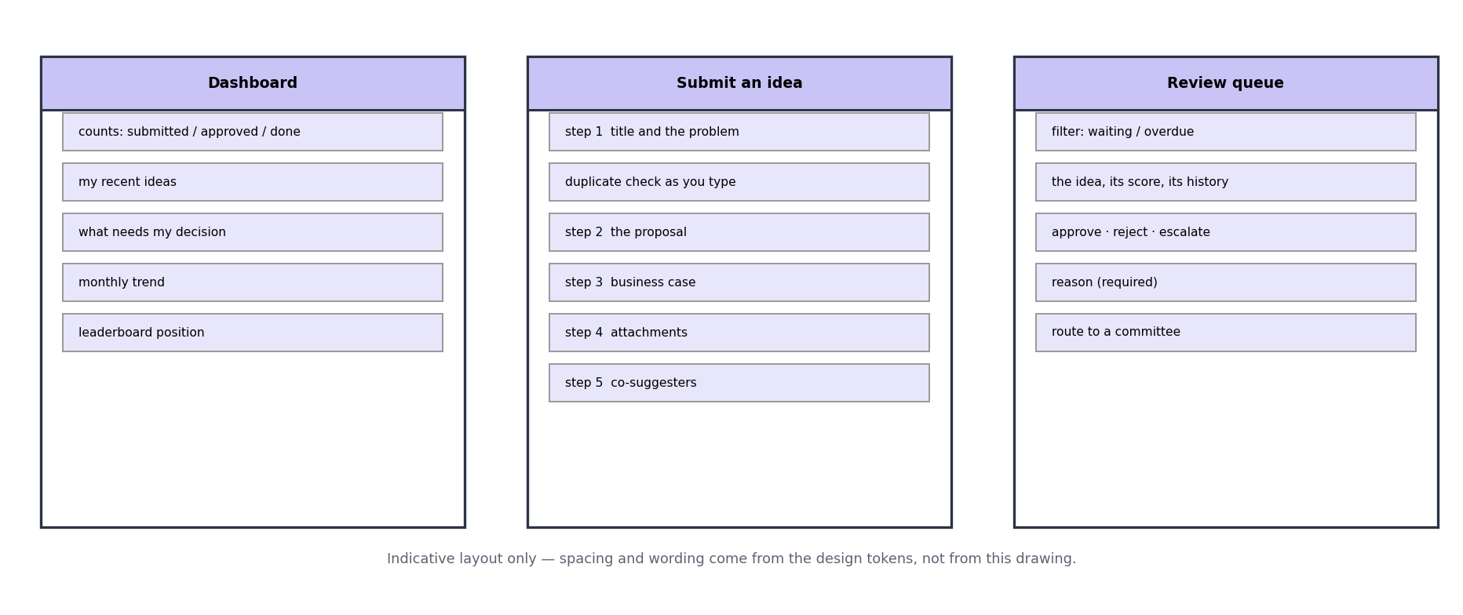
Legend: Rough layouts, not final visuals. Square brackets are controls.

14.1 Interface principles
Principle | What it means
The landing page explains before it asks | A business arriving for the first time gets an explanation of the product, not a password box. Signing in is one click away for people who already have an account.
Long forms are broken into steps | The submission form is six short steps rather than one long page, so nothing is abandoned halfway.
Jargon is explained where it appears | 60 small information buttons sit beside technical terms. They open on hover for a mouse, on tap for a phone, and on keyboard focus. A phone user gets the same help as everybody else.
Required fields are obvious before the error | Marked with a red asterisk. Previously they were the same colour as the label and read as punctuation.
Detail opens over the list | Reading an idea does not lose your place in the list you were working through.
Colour is never the only signal | Feasibility is red, amber and green, but always with the word as well.
Everything works in seven languages | Chosen per person, not per organisation, because a shop floor and an office rarely share one language.

PART D - RUNNING THE SYSTEM

15. Deployment Architecture
Where the system runs today, and how a change gets from a developer's machine to the live site.
Figure A-5 Deployment
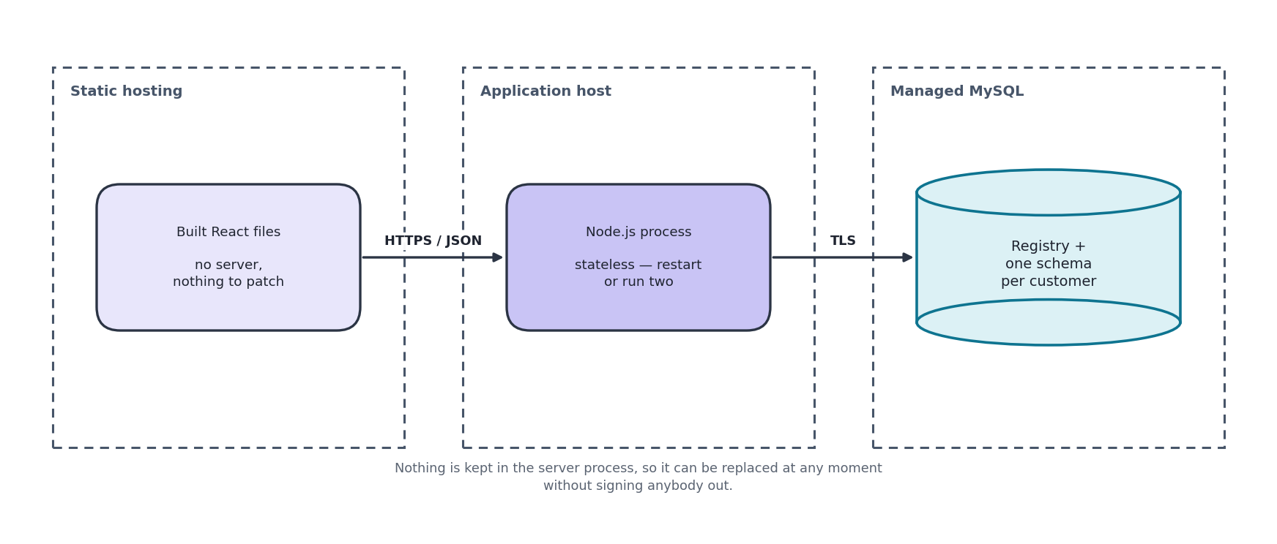
Legend: Arrows are automatic unless labelled otherwise.

15.1 Environments
Environment | Screens | API | Database | Purpose
Development | Local, port 5173 | Local, port 4000 | Local MySQL or XAMPP | Day-to-day work
Live (current) | Vercel | Render | Aiven managed MySQL | Demonstrations and user acceptance testing
Production (planned) | Azure Static Web Apps | Azure App Service | Azure Database for MySQL | Paying customers - see ADR-009

15.2 Known limitations of the current hosting
Limitation | Effect | What fixes it
The API sleeps after 15 minutes idle | The first request after a quiet period takes about a minute | A paid tier, or the move to Azure
The disk is temporary | Uploaded files vanish when the API restarts, while their database records survive. An attachment appears in a list and then fails to open. | Move files to object storage. This is the first task in the production plan
The database is capped at 1 GB | Fine for demonstrations, not for several real customers | A paid database tier
Email is not configured | Password resets and notifications are silently not delivered | Configure an SMTP server per organisation

16. Security Architecture
Security is arranged as six layers. A request has to clear all six, and each layer assumes the ones above it were passed.
Figure A-6 Security layers
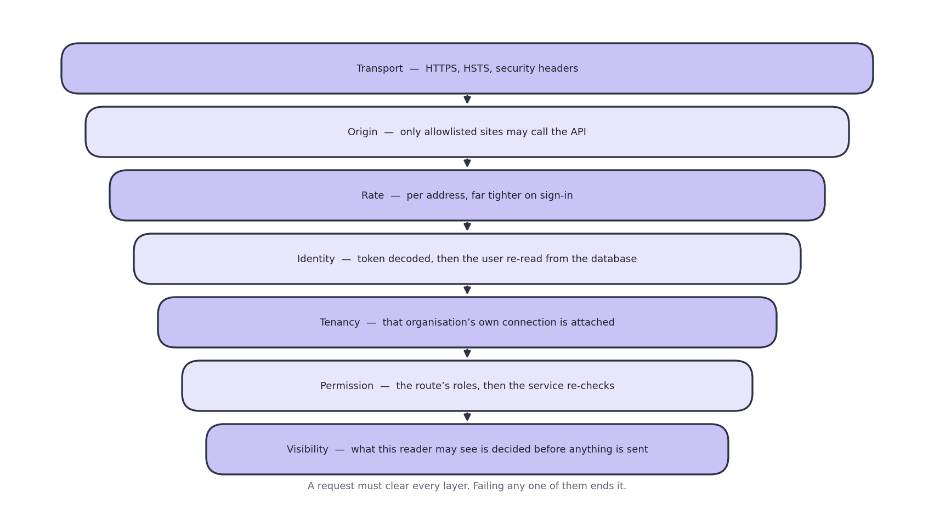
Legend: Each layer assumes the ones above it were passed. A request must clear all six.

16.1 Roles and what they can reach
Role | Can see | Can do
Trainee, Employee | Their own ideas in full; titles and summaries of others | Submit, vote, comment
Team lead, Project lead | Their team's ideas | The above, plus review
Manager, Department manager, Senior manager | Their reports' ideas, in full | Review and pass onward
Plant head | Every idea in the organisation | Final approval
Executive | Every idea in the organisation | Review
Organisation admin | Everything in their own organisation | All of the above, plus people, settings, archiving, exports
Super admin | Everything in their own organisation | As organisation admin. Deliberately removed from the approval chain
IFQM platform admin | Counts and totals for every organisation. No idea content, ever | Create and pause organisations, approve applications, handle tickets

16.2 Decisions worth explaining
Decision | Why
The user is re-read from the database on every request | A session token stays valid for eight hours. Trusting it meant that removing an employee did not end their access, demoting someone left their old powers in place, and resetting a password did not close sessions opened with the old one.
A password check runs even when the account does not exist | Skipping it answered 'no such account' in about five milliseconds and 'wrong password' in about 250. That difference alone let anyone work out who works at a company.
Lockout counters are stored in the database | They used to be held in memory, which meant they reset on every restart, did not exist across two servers, and grew without limit.
Browse lists never carry full idea text | The screen only showed a snippet, but the whole text was in the response and readable by anyone who opened the browser's network tab. Truncating on screen is not privacy.
Super admin is not in the approval chain | Whoever holds that password is usually somebody in IT, not the person qualified to judge a shop-floor improvement.
Content protection is offered but described honestly | It blocks right-click, selection and copying, and stamps the reader's name across the text. It cannot stop a screenshot or a phone camera and the help text says so. Its real value is that a leaked screenshot carries a name.
One-time codes are bcrypt-hashed like passwords | A six-digit code in a plain column would let anyone with read access to the registry sign in as any user with a code outstanding - an easier secret to use than a password hash, and outstanding for exactly as long as somebody is trying to sign in.
Codes are drawn from a cryptographic random source | Math.random() is predictable from previous output, so an attacker who had seen one code could compute the next. The digits are rejection-sampled so the modulo does not bias the low ones.
The code option is hidden unless a code can actually be delivered | Offering it while the gateway is misconfigured is worse than not offering it: the user abandons a password that works for a code that never arrives, and the sign-in screen has no way to explain itself.
The mock SMS provider is refused under NODE_ENV=production | It writes the code to the server log instead of sending it, which is what makes testing possible before a gateway contract exists. In a live system that is a credential leak and a silent failure at once, so it fails closed rather than pretending.
Maintenance mode is enforced after the platform-admin branch, not by a role check | The gate sits at a point in the sign-in path that IFQM staff never reach, so they are exempt by the shape of the function. A role check could be got wrong later, and getting it wrong means nobody can sign in to switch maintenance back off.
Maintenance mode fails open if the registry cannot be read | The console used to switch it off reads the same database. A blip that was treated as 'assume on' would be a platform-wide lockout that nobody could clear.

16.3 Putting the platform on hold
Maintenance mode stops every organisation using the system while an update is carried out, and leaves IFQM's own staff able to work. That asymmetry is the whole feature: somebody has to be able to see the platform in order to decide it is safe to turn back on.
It is enforced in three places, because any one of them alone leaves a door open:
- At password sign-in, so no new session can be obtained.
- At the one-time-code routes, on both request and redemption - the login screen offers a code as an alternative to a password, so the two are the same door and both have to be shut. A code issued a minute before the switch must not still buy a session after it.
- On every authenticated request, so a session opened before the switch stops working. Without this, 'on hold' would mean nothing to anybody already signed in, which is most people during a working day.
Signing out is deliberately still allowed. A tenant whose session is being refused should be able to clear it and land on the sign-in screen, which is where the notice is; leaving them holding a token that every other endpoint rejects is a worse dead end than the one being prevented. The flag is cached for a few seconds and dropped on write, because it is read on every authenticated request and changes roughly never.

17. Integration Architecture
Four outside services, all optional, all configured per customer, and all outbound. Nothing external can call into the system.
Figure A-7 Integrations
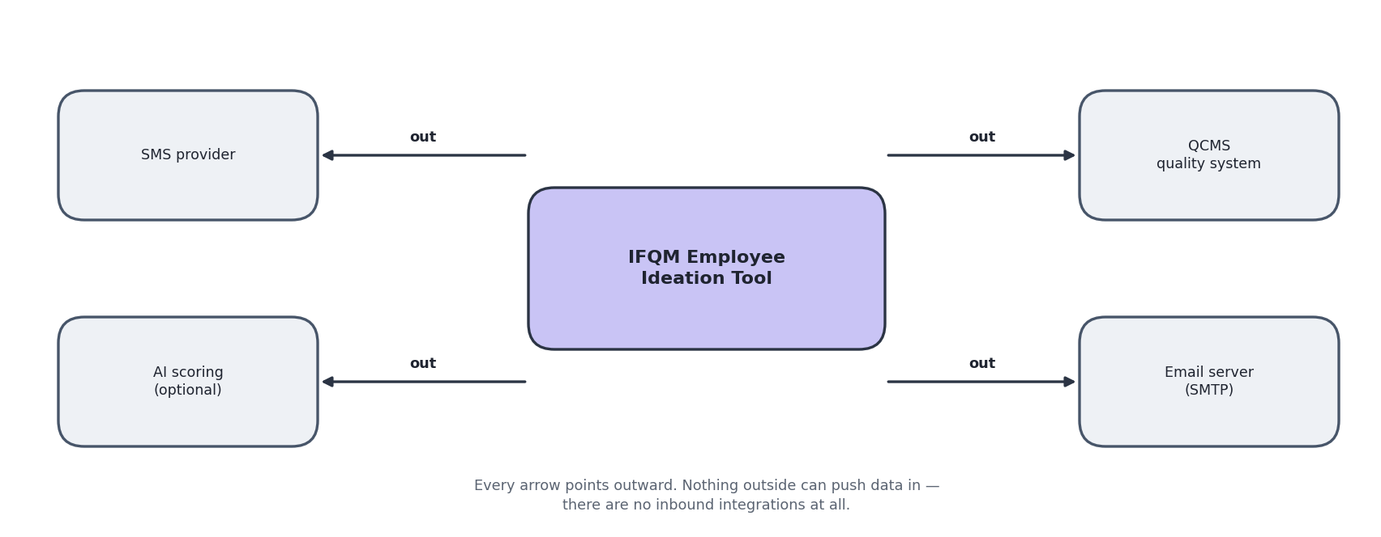
Legend: Arrows point the way data travels. There are no inbound integrations.
Integration | Direction | Trigger | If it fails
QCMS | Out | An administrator pushes an approved idea | The failure is recorded against the idea and it can be retried. A duplicate is treated as success, because the idea has arrived and retrying would create a second
Email (SMTP) | Out | Password reset, notifications, one-time codes | Queued and retried. Where the host blocks outbound SMTP the sender falls through to the provider's HTTPS API instead, then stops attempting SMTP for a few minutes
Email (HTTPS API) | Out | Same messages, when SMTP cannot be reached | The caller is told the code could not be sent. Nothing is queued behind it
SMS gateway | Out | A one-time code, by text | The code is sent by email instead where an address is on file, and the fallback is logged. Password sign-in is unaffected
AI scoring | Out | An idea is submitted, only if a provider is configured | Falls back to the built-in scorer. The submission still succeeds

Worth stating plainly for customer conversations: with no AI provider configured, which is the default, no idea text leaves the system at all. Scoring runs inside the application.

17.1 One-time codes, by text and by email
A one-time code is a six-digit secret sent to something the person already holds - a mobile number or an email address - and exchanged for the same session a password would have produced. It is used in five places, and the same service issues and checks the code in all of them.
Purpose | Where it is used | Channel
login | Signing in with a code instead of a password | Text, or email if the person typed an address
registration_verify | An organisation applying to join proves it holds the address | Email
registration_phone | The same application proves it holds the mobile number | Text
password_reset | Resetting a password without reaching the emailed link | Either
phone_verify | Confirming a number somebody has just added or changed | Text

Codes are stored bcrypt-hashed, never in clear. A plain six-digit column would let anyone with read access to the registry sign in as any user with a code outstanding - the same mistake as storing passwords in clear, and a far easier secret to use than a password hash. The digits exist in memory for the length of one request and are never written down, which is also why the delivery log records that a message was sent and never what it said.
Four rules bound what a code can do, and each exists because of a specific attack:
- It expires in five minutes and can be redeemed exactly once. Marking it consumed happens before the session is minted, so two requests arriving together cannot both succeed.
- Wrong guesses are counted per code, and the fifth destroys it. Six digits is a million possibilities, which sounds like a lot until you notice an attacker has the whole validity window and can guess as fast as the network allows.
- Issuing a new code expires the previous one. Otherwise every resend adds another live code and the guessing space shrinks with each click.
- Requesting a code says nothing about whether the identifier is registered. The reply is identical either way, and no row is written for an unknown one - otherwise the endpoint becomes a way to type numbers and learn who works there.
The registration form is the deliberate exception to that last rule: it reports honestly whether the code was sent. The applicant is typing their own details into a form they are filling in, so there is nothing to give away, and a form that cannot say "that did not send" leaves somebody waiting for a code that is never coming.

17.2 What the mobile operator requires
Indian operators will not carry commercial text unless it is registered in advance, and an unregistered message is dropped by the carrier with no error and no delivery report - which looks exactly like a bug in this application. Three registrations travel with every message:
Registration | What it is | Consequence if wrong
Principal Entity ID | The business, registered once on the operator's portal | Message rejected at the gateway
Header / Sender ID | The six-character name the recipient sees instead of a number | Rejected; a header of any other length is a transcription slip
Content Template ID | The exact approved wording, one per purpose | Accepted by the gateway and then dropped by the carrier, silently

The last row is the one that costs time. The carrier compares the text against the template the id claims, placeholder for placeholder, so the wording is configuration rather than a string in the source: if the two ever drift - because somebody edited the sentence to read better - every message starts being dropped and the cause is invisible from inside the application. The gateway answering "accepted" is not evidence of delivery, and the console says so rather than reporting success.
Where only one template registration is available, every purpose is sent under that one - its id and its wording together, because the carrier checks the two against each other. Sending approved wording under a different purpose's id fails just as surely as sending unregistered text.

18. Error Handling and Exception Flow
Two kinds of problem, handled differently on purpose.
Figure D-15 How a failure is handled
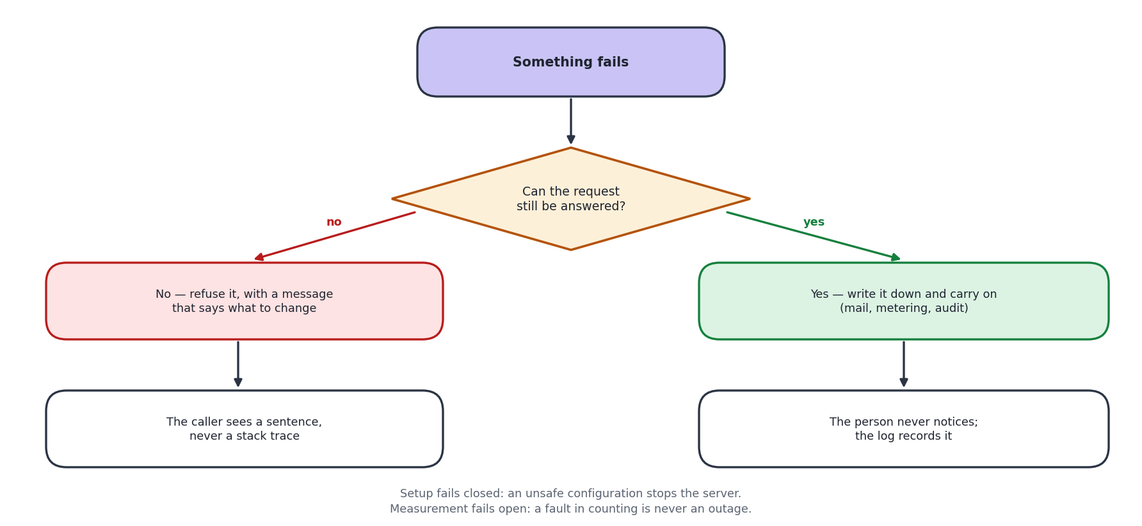
Legend: Numbers are the standard web status codes the API returns.

18.1 The principle
A problem we anticipated gets a specific, useful message: which field was wrong, how many sign-in attempts remain, which limit was reached. A problem we did not anticipate gets a generic message and a full entry in the log.
The reason for the difference is that raw database errors name tables, columns and file paths. Showing one to a user hands an attacker a map of the system. So the detail goes to the log, where the people who need it can find it, and the user gets a sentence.

18.2 Things that fail quietly, and why
Operation | Why a failure is swallowed
Writing a sign-in record | An audit trail that can stop a sign-in turns a logging outage into an outage
Sending a notification | A mail server being slow must not make submitting an idea fail
Counting API usage | A fault in measuring must never become an outage for the customer
Updating the sign-in directory | It repairs itself on the next sign-in

18.3 Things that fail loudly, and why
Situation | What happens
Weak or missing session signing key | The server refuses to start and says so
Blank database password, or the root account in use | The server refuses to start
Settings still pointing at a developer machine | The server refuses to start
The registry cannot be reached, in production | Sign-in is refused rather than falling back to a default organisation, which would authenticate somebody against the wrong customer's data

19. Logging and Monitoring

19.1 What is written down
Kind | Where | Kept | Contains
Application log | Standard output, collected by the host | Host's retention | Start-up, requests, warnings, errors with stack traces
Request log | Same | Same | Method, path, status, time taken
Sign-in activity | Registry table | 180 days | Who, when, from what address and browser, success or failure
Idea history | Per organisation, in the database | Life of the idea | Every status change, who made it, when, and the comment
Import errors | Per organisation | Life of the job | Row number and reason
API usage | Registry table | Rolling | Requests per organisation per month

19.2 What is never logged
- Passwords, in any form.
- One-time codes, except in the deliberate test-only mode, which refuses to run in production for exactly this reason.
- The QCMS key.
- Full phone numbers - the last four digits only.
- Idea content.

19.3 Health checks
Check | Answers | Use
/api/health | The process is running | A load balancer's basic check. Deliberately does not touch the database
/api/ready | The process can reach the registry | The check to point orchestration at. A server that is up but cannot reach its database is worse than one that is down, because it answers every request with an error

19.4 Gaps to close before production
- No alerting. Somebody has to look at the logs. An uptime check with an email alert is the cheapest first step, and both health endpoints already exist for it to call.
- No error aggregation. A tool that groups repeated errors would make patterns visible that a flat log hides.
- No dashboard for sign-in failures, which is the signal that matters most for abuse. The data is already recorded; nothing displays it as a trend.
These three are carried forward into section 26.2, which is the single consolidated list of everything not yet done.

20. Performance and Scalability

20.1 What has already been done
Measure | Reason
Indexes on the columns lists are sorted and filtered by | Under load testing, the ideas list was scanning the whole table and sorting it on every request. At a few thousand rows that is cheap; at hundreds of thousands it consumed the connection pool and requests started failing. With the index the database reads in order and stops at 100 rows
Every list is capped and paged | The user list used to return every employee in one response. Bulk import can put several thousand people in there, and sending all of them would hang the very screen an administrator lands on after importing
Searching and filtering happen in the database | So the browser never receives rows it is only going to hide
Password checks do not block the server | The synchronous version occupies the process for the full quarter-second of hashing, during which nobody else is served. A morning sign-in rush made login latency into everybody's latency
One connection pool per organisation, reused | Opening a connection per request is the most expensive thing a small application usually does
Usage counting is buffered | Writing a counter on every request would put a database round trip in front of every call, to protect against something that happens once a month

20.2 Where it would strain first
Growth | First thing to give way | Answer
More organisations | Database connections. Each organisation holds its own pool | Reduce the pool size per organisation, or close idle pools. Both are settings
Many more staff in one organisation | The org chart screen, which loads the whole tree | Load one level at a time
Many more ideas | The idea board, which is an unfiltered wall of cards | Add filters and paging to the board
Sustained heavy traffic | The API is a single process | Run several. The design already allows it - sessions hold no server-side state
Many attachments | Local disk | Object storage. Needed anyway for the current hosting

For the size of customer this is sold to - 20 to 500 staff - the current design has considerable headroom. The strain points above are worth knowing, not worth pre-emptively engineering.

21. Backup and Disaster Recovery

21.1 What is backed up
What | How | How often | Kept
Registry database | Managed provider snapshots | Daily, plus point-in-time | Per the provider's plan
Each organisation's database | Same | Daily, plus point-in-time | Same
Uploaded files | NOT BACKED UP on the current hosting | - | This is the biggest gap. See below
Code and schema | Git history | Every change | Indefinitely
Configuration | Host's settings store | On change | Current values only

21.2 The gap that needs closing first
Uploaded files sit on the application server's own disk. On the current hosting that disk is wiped whenever the server restarts, and it is not backed up at all. The database records describing those files survive, so the result is an attachment that appears in a list and fails to open.
Moving files to object storage fixes the backup gap and the disappearing-files problem in one change, and it has to happen before any customer stores anything they would miss. It is the first item in the production plan.

21.3 Recovery targets
Scenario | Target time to recover | Expected data loss | How
Application server fails | Under 15 minutes | None | Redeploy. The API holds no state of its own
Database corrupted or wrong data written | 1 to 4 hours | Up to 5 minutes | Point-in-time restore to just before the problem
One organisation's data damaged | 1 to 2 hours | Up to 5 minutes | Restore that one database. Others are untouched, which is a direct benefit of the separate-database design
Whole hosting region lost | 4 to 24 hours | Up to 24 hours | Restore into another region from the latest snapshot
Files lost | Not currently recoverable | All files | Until object storage is in place, this cannot be recovered. Stated plainly rather than glossed over

These targets have not been rehearsed. A restore that has never been tested is an assumption, not a plan, and a rehearsal should be scheduled before the first paying customer.

22. Testing Strategy

22.1 What exists today
Level | What it covers | How many | How it runs
Integration tests | The API end to end against a real database - sign-in, roles, tenant separation, lockout arithmetic, anonymity, approvals, QCMS, billing | 37, all passing | npm test
Assurance suite | One scripted case per requirement across 22 areas, from authentication to fault tolerance and scalability. Writes a results file and a printable test-case document | 229 cases, 228 passing | node test/tc_runner.mjs
Migration checks | Every schema file applied twice under strict database settings | All 20 migrations | Script
Targeted verification | Written for each risky change - quotas, one-time codes, visibility rules, the hierarchy template | As needed | Scripts, run during development

The one failing case is deliberate and is left failing rather than skipped: it compares the interface strings across the seven languages and reports the 294 that exist in English and not in the other six. It will pass when the translation work in section 26.3 is done, and until then it is the thing that stops that gap being forgotten.

22.2 What the integration tests deliberately cover
They are not there for coverage figures. Each one exists because the thing it checks either broke once or would be severe if it broke.
- One organisation cannot read another's data.
- A role cannot reach an endpoint it should not.
- Lockout counts correctly - an off-by-one here locks people out a try early.
- An anonymous idea stays anonymous everywhere, including in the approval history.
- The approval chain routes and escalates correctly.
- A password change ends sessions opened with the old password.

22.3 Gaps
Gap | Risk | Suggested answer
No automated screen tests | A screen can break without a test noticing | A handful of browser tests over the critical paths: sign in, submit, approve
No load testing since the indexing work | Performance could regress unnoticed | A scripted run before each release
No penetration test | Requested in the minutes, not yet done | Commission one before the first paying customer
No user acceptance testing | Also requested, and not yet run | Run it on the current live deployment, which exists for this purpose
Tests need a real database | Cannot run on a machine without MySQL | Acceptable, and deliberate - the things being tested are database behaviour

All of these except the last are carried forward into section 26.1, with what closing each one would actually take.

23. Deployment and Release Plan

23.1 How a change reaches the live site
Step | What happens | Who
1 | Write the change and run the tests locally | Developer
2 | If the database changes, write a numbered migration file and apply it locally | Developer
3 | Commit and push to the main branch | Developer
4 | The screens and the API rebuild automatically | Automatic
5 | Run the migration against the live database, deliberately | Developer
6 | Check the health endpoint and try the changed feature | Developer

23.2 The rule about database changes
Migrations are forward-only. Fixing a bad migration means writing a new one, never editing a file that has already been applied - copies that already ran cannot be retro-edited. A ledger records which migration has been applied to which database, so re-running applies only what is missing.
Order matters when a change is not backwards-compatible. A migration that adds something goes before the code that needs it; one that removes something goes after. Getting this the wrong way round causes a short outage.

23.3 Rollback
Problem | How to undo it
Code is faulty | Both hosts keep previous deployments; roll back with one click
A migration is faulty | Write and apply a new migration that corrects it. Never edit the original
Data is wrong | Point-in-time restore of that organisation's database

23.4 Before the first paying customer
# | Task | Why it blocks
1 | Move uploaded files to object storage | Files are currently lost on restart and are not backed up
2 | Configure an SMTP server | No password reset or notification email is delivered
3 | Move to paid hosting | Cold starts and a 1 GB database cap
4 | Rehearse a restore | The recovery plan is untested
5 | Run user acceptance testing | Requested in the minutes
6 | Commission a penetration test | Requested in the minutes
7 | Set up uptime alerting | Nobody is currently told when something breaks

Section 26.4 puts these in the order they should actually be done, alongside the items that do not block a first customer but still need doing.

PART E - DECISIONS, TRACEABILITY AND OUTSTANDING WORK

24. Architecture Decision Records
The decisions that shaped the system, each with the reason and what it cost. The point of writing these down is that in a year somebody will look at one of these choices, think it is odd, and change it. This is so they can see what it was for before they do.

ADR-001 A separate database for every customer
Status | Accepted
Context | Customers are businesses who expect their staff list and their ideas to be nobody else's business. Sharing tables and filtering by a customer column is the common approach, but it means one missing WHERE clause leaks between customers.
Decision | One database per organisation, plus a small shared registry recording which organisations exist.
Consequences | Separation you can point at in a sales conversation. A restore affects one customer. The cost is more databases to migrate, and a connection pool per customer, which is the first thing that will strain as the number of customers grows.

ADR-002 Sessions as signed tokens, but the user re-read every time
Status | Accepted
Context | Server-held sessions would tie a user to one server and complicate restarts. Tokens solve that, but a token stays valid until it expires - so removing an employee did not end their access.
Decision | Use a signed token for identity, but read the user back from the database on every request and check the role and password timestamp.
Consequences | Removals, demotions and password resets take effect immediately. The cost is one small indexed query per request, which is a fair price for correct access control.

ADR-003 Raw SQL rather than an object-relational mapper
Status | Accepted
Context | An ORM saves work on simple applications. Here the central concern is choosing which database a request talks to, which is exactly what an ORM abstracts away.
Decision | Use the MySQL driver directly with prepared statements.
Consequences | The queries that matter most are visible and reviewable. The cost is more code, and discipline about parameter binding - helped by prepared statements being the default.

ADR-004 Scoring built in, external providers optional
Status | Accepted
Context | Sending idea text to an outside company is a real concern for customers, and an API key is a barrier for a small business.
Decision | A scorer inside the application is the default. OpenAI or Gemini can be configured but are off unless chosen.
Consequences | The product works with no account and no cost, and by default no idea text leaves the system. The built-in scorer is less nuanced, which is an acceptable trade for a sorting aid.

ADR-005 Full idea text is never sent to a browse list
Status | Accepted
Context | The list query originally selected every column, so the full text of every idea was delivered to every employee's browser. The screen showed a snippet, which hid it from the reader but not from the page.
Decision | Browse endpoints send a one-line summary and nothing more. The full text comes only from the single-idea endpoint, and only to people entitled to it.
Consequences | The protection is real rather than cosmetic. The cost is a second request to read an idea in full, which is what a person does anyway.

ADR-006 Archiving instead of deleting
Status | Accepted
Context | Administrators need old ideas out of the way. Deleting them would destroy the points awarded, the approval history and the recorded savings - the very evidence the scheme is judged on.
Decision | Archiving sets a date. Everything is retained and it can be reversed.
Consequences | Nothing is lost and reports stay correct. The cost is that every list has to filter on it, which is why the column is indexed.

ADR-007 One-time codes stored hashed, with a provider interface
Status | Accepted
Context | A six-digit code in plain text would let anyone reading the table sign in as that user. And no SMS provider had been chosen when the feature was asked for.
Decision | Hash the code exactly as a password. Send it through a provider interface with three implementations, one of which writes to the log for testing and refuses to run in production.
Consequences | The feature could be built and tested before a supplier existed, and changing supplier is a setting. The cost is a hash comparison per attempt, which is negligible.

ADR-008 Approval chain expressed as ordered stages
Status | Accepted
Context | Organisations describe approval as an order - originator, then manager, then department head - not as two unordered lists of roles.
Decision | Store the ordered list. Derive the reviewer and final-approver sets from it, so the engine underneath never learns that stages exist.
Consequences | The admin screen can add, remove and reorder steps, and the preview is honest. The cost is two ways of expressing the same chain, which is why both are derived from one definition.

ADR-009 Target Microsoft Azure for production
Status | Proposed
Context | The system runs on a free-tier arrangement that is fine for demonstrations and wrong for customers. Azure, AWS and a plain virtual server were compared.
Decision | Recommend Azure App Service with Azure Database for MySQL and Blob Storage.
Consequences | Not chosen on price - the three are close at this size. Chosen because single sign-on is already committed to Microsoft Entra ID, and federating a different cloud's identity system to it is the expensive part. A plain virtual server is cheapest and was rejected because patching, upgrades, backups and certificates all become a named person's recurring job, which is the opposite of what a handover needs.

ADR-010 Move uploaded files to object storage
Status | Proposed
Context | Files sit on the application server's disk. That is fine on one permanent machine and wrong the moment there are two, or the platform replaces the machine - which is exactly what the current hosting does.
Decision | Move attachments to object storage before production.
Consequences | Fixes disappearing attachments and the backup gap in one change. Contained: three modules write files. Must happen before any customer stores anything they would miss.

ADR-011 Defer single sign-on
Status | Deferred
Context | Requested in the minutes, across QCMS, DWM and Skills.
Decision | Not built. The sign-in path was structured so that a new method returns the same session as any other, which one-time codes have now demonstrated.
Consequences | Adding single sign-on later is an addition rather than a rewrite. Blocked on an Azure tenant and agreement from two other tools.

ADR-012 Free email domains blocked at registration
Status | Accepted, with a conflict
Context | An ideation platform is sold to a business. An address anyone can create in a minute is no evidence the applicant speaks for a company.
Decision | Refuse consumer and disposable email domains, and require a human to approve every application anyway.
Consequences | Keeps the review queue readable. But the same minutes also ask to accept a personal address for businesses with no domain of their own. Both cannot be true. Free mail is blocked today, so a sole trader cannot register. This needs a decision - it is the one genuinely open question in this document.

25. Requirements Traceability Matrix
Every requirement mapped to the part of the system that implements it, the diagrams that describe it, and how it is verified. This is the table to use when asking whether something was actually built.

25.1 Functional requirements
Table 25.1 All 42 functional requirements, mapped to code, diagram and check
Req | Implemented in | Diagrams | Verified by | State
FR-01 | authService, auth middleware | D-7, A-6 | Integration tests | Done
FR-02 | otpService, smsService | A-6 | Six scripted security checks | Done
FR-03 | authService | A-6 | Integration tests | Done
FR-04 | userImportService | A-4 | Integration tests | Done
FR-05 | ideaService, submit screen | D-1, D-8, D-14 | Integration tests, manual | Done
FR-06 | ideaService.checkDuplicate | D-8 | Manual | Done
FR-07 | ideaService.submitOrDraft | D-1 | Integration tests | Done
FR-08 | aiService | D-8 | Integration tests | Done
FR-09 | approvalStages, ideaService | D-1, D-9 | Integration tests | Done
FR-10 | ideaService escalation | D-9 | Integration tests | Done
FR-11 | ideaService.reviewAction | D-9 | Integration tests | Done
FR-12 | ideaService review stage | D-1 | Scripted check | Done
FR-13 | ideaService ROI and implementation | D-1 | Integration tests | Done
FR-14 | leaderboardService, coreHelpers | D-1 | Integration tests | Done
FR-15 | votingService, commentService | D-1 | Integration tests | Done
FR-16 | challengeService | A-4 | Manual | Done
FR-17 | ideaService.redactSolution | A-6, D-3 | Scripted, three modes | Done
FR-18 | settingsService, org settings | A-6 | Scripted, three modes | Done
FR-19 | ideaService.setArchived | D-5 | Scripted check | Done
FR-20 | ideaService.setPatentability | D-5 | Scripted check | Done
FR-21 | exportService, screen export | D-14 | Manual | Done
FR-22 | Rejected ideas screen | D-13 | Manual | Done
FR-23 | userImportService | A-4 | Integration tests, 500-row sample | Done
FR-24 | hierarchyTemplateService | A-4 | Round-trip script incl. refusals | Done
FR-25 | userService.adminUsers | A-4 | Scripted check | Done
FR-26 | registrationService | D-10 | End-to-end script | Done
FR-27 | registrationService domain check | D-10 | End-to-end script | Done
FR-28 | registrationService.approve | D-10 | End-to-end script | Done
FR-29 | platformService | A-1, D-6 | Integration tests | Done
FR-30 | platformService privacy contract | A-1, D-6 | Integration tests | Done
FR-31 | activityService | A-6 | Scripted check | Done
FR-32 | qcmsService, integrationService | A-7, D-11 | Integration tests | Done
FR-33 | settingsService, brandingService | A-4 | Manual | Done
FR-34 | Language files | A-3 | Automated key check | Partial - 294 keys short in six languages
FR-35 | supportService | A-4 | Manual | Done
FR-36 | planService (priceBreakdown, decoratePlan) | D-4, D-6 | Integration tests | Done
FR-37 | registrationService.approveRegistration, subscriptionService.assignPlan | D-4, D-10 | Integration tests | Done
FR-38 | subscriptionService.setTrialDays, defaultTrialDays | D-4 | Integration tests | Done
FR-39 | subscriptionService (billingState, sweepLapsed) | D-4 | Integration tests | Done
FR-40 | platformService.tenantDetail | A-1, D-6 | Manual | Done
FR-41 | tenantQuota middleware, migration 018 | A-6 | Integration test incl. the lock-out guard | Done
FR-42 | NotFoundPage, Breadcrumbs, PageMeta, HelpPage | D-13 | Browser check | Done

25.2 Non-functional requirements
Table 25.2 All 18 non-functional requirements
Req | Implemented in | Diagrams | Verified by | State
NFR-01 | database/tenant.js, auth middleware | A-2, D-4, D-5 | Integration tests | Done
NFR-02 | ideaService redaction | A-6 | Scripted, all modes and roles | Done
NFR-03 | auth middleware re-read | A-6, D-7 | Integration tests | Done
NFR-04 | bcrypt in authService | A-6 | Integration tests | Done
NFR-05 | app.js, config | A-6 | Live check | Done
NFR-06 | rateLimiter, tenantQuota | A-6 | Scripted quota test | Done
NFR-07 | Indexes, paging | - | Load testing | Done
NFR-08 | Server-side search and paging | - | Manual with 500 users | Done
NFR-09 | Best-effort writes | D-15 | Code review | Done
NFR-10 | Managed backups, backup script | - | Not yet rehearsed | Partial
NFR-11 | idea_workflow, login activity | D-5 | Integration tests | Done
NFR-12 | Information buttons, glossary | D-14 | Browser check | Done
NFR-13 | Focus outlines, responsive layout | D-14 | Manual | Partial
NFR-14 | Seven language files | A-3 | Automated key check | Partial - 294 keys short
NFR-15 | Standard Node and MySQL | A-3, A-5 | Runs on three hosts | Done
NFR-16 | Layered services, technical manual | A-4 | Review | Done
NFR-17 | Registration and import field sets | D-4 | Review | Done
NFR-18 | config.assertConfigOrExit | D-15 | Integration tests | Done

25.3 Requirements not fully met
Two of the sixty rows above say Partial rather than Done. Both are listed again in section 26 with what it would take to close them. Every other requirement in this matrix has working code behind it and a way of checking it.
Req | What is short | What would close it
FR-34 / NFR-14 | English carries 1,116 interface strings; each of the six other languages carries 822. The 294 newest strings fall back to English rather than breaking the screen. | A translation pass over the newer screens. The mechanism is finished - this is content
NFR-13 | Focus outlines, keyboard reach and reflow are in place and were checked by hand. No assistive technology has been used against the product and no standard has been claimed. | An accessibility review against a named standard, if one is going to be claimed

26. Work Not Yet Done
Everything above describes what exists. This section is the other half of an honest handover: the things a reader might reasonably assume are in place and which are not. Nothing here is a defect. They are pieces of work that have not been started, or have been done but never exercised - and the difference between those two matters, because an untested backup is more dangerous than an absent one, since somebody is relying on it.

26.1 Assurance not yet carried out
Item | Where it stands | Risk of leaving it | What closing it takes
User acceptance testing | Not run. The live deployment exists for exactly this and is working. | The people who will use the product every day have not yet said whether it fits how they actually work. That is the feedback most likely to change a screen. | Scheduling with a customer, and someone to sit with them. No engineering work
Penetration testing | Not commissioned. Requested in the minutes of 29 July 2026. | The security work in section 16 was designed and reviewed by the people who wrote it. That is not the same as being tested by somebody trying to break it. | A budget and a firm. Should be done before the first paying customer
Backup restore rehearsal | Backups are being taken. No restore has ever been performed from them. | The single largest one here. The recovery targets in section 21.3 are estimates, not measurements. A backup nobody has restored from is an assumption. | Half a day: restore a snapshot into a scratch database and confirm an organisation comes back whole. Repeat quarterly
Automated screen tests | None. The 37 integration tests and the 229-case assurance run both work against the API, not the interface. | A screen can break without anything failing. | A handful of browser tests over sign in, submit and approve
Load testing since the indexing work | Done once, before the indexes were added; not repeated since. | Performance could regress without anybody noticing. | A scripted run before each release

26.2 Operational gaps
Item | Where it stands | Risk of leaving it | What closing it takes
Monitoring and alerting | Nothing. Logs are written and health checks answer, but nobody and nothing is watching them. | The first person to know the site is down is a customer. Both health endpoints already exist and are unused by any monitor. | An uptime service pointed at /api/ready with an email alert. An hour's work and a small monthly cost
Error aggregation | Errors go to a flat log on the host. | A fault that happens forty times in an hour looks the same as one that happened once. | A hosted error tracker, or a scheduled digest of the log
A view of sign-in failures | The data is recorded in the registry; nothing displays it as a trend. | Repeated failed sign-ins are the clearest signal of abuse, and it is currently only visible by reading rows. | One chart on the platform console over data that is already there
Object storage for attachments | Files are on the application server's own disk. On the current hosting that disk is wiped on restart and is not backed up. | Attachments already disappear while their database records survive, so a file appears in a list and fails to open. This is a live defect, not a future one. | Three modules write files, so the change is contained. It is the first task in the production plan and must happen before a customer stores anything they would miss
SMTP in production | Not configured. The queue works; nothing delivers from it. | Password resets and notification emails are silently not sent. | Credentials for a mail service, set per organisation

26.3 Content and feature work
Item | Where it stands | Risk of leaving it | What closing it takes
Translation completeness | English 1,116 strings; Hindi, Kannada, Malayalam, Marathi, Tamil and Telugu 822 each. The gap is the 294 newest strings. | A shop-floor user on a Tamil interface meets English text on the newer screens. It works, but it undercuts the claim that the product speaks seven languages. | A translation pass. The lookup mechanism, the fallback and the automated key check are all finished - this is content, not code
Single sign-on with Entra ID | Not built. The sign-in path was deliberately shaped so a new method returns the same session as any other, which the one-time-code route has already demonstrated. | Nothing breaks; it stays a separate password. | An Azure tenant, plus agreement from QCMS, DWM and Skills. An addition rather than a rewrite - see ADR-011
Taking payment | Plans, pricing with GST, trials, holds and the billing history are all built. No payment gateway is connected and no invoice is generated. | None operationally - money is collected outside the product today and a member of the platform team records it. It is only a gap if self-service payment is wanted. | A gateway integration and invoice generation. The plan and period data it would need is already recorded
Registration for a business with no domain | Blocked on a decision, not on work. Free email domains are refused, so a sole trader cannot apply. | A segment of the intended market cannot register at all. | A decision. The minutes ask for both this and the domain rule, and both cannot be true - see ADR-012. This is the one genuinely open question in this document

26.4 The order they should be done in
# | Item | Why it goes here
1 | Object storage for attachments | It is the only item on this list that is losing data right now
2 | Configure SMTP | Password reset does not work without it
3 | Uptime alerting | An hour of work, and it changes who finds out first
4 | Rehearse a restore | Turns section 21.3 from estimates into measurements
5 | User acceptance testing | Feedback is cheapest before more is built on top
6 | Penetration test | Wants a stable target, so after the four above
7 | Translation pass | Content work, and it can run alongside anything else
8 | Decide the free-email question | Needs a person, not a sprint. See ADR-012

Closing note
This document describes the system as it actually stands, not as it was planned. Where something is incomplete it says so, and where a limitation exists - the disappearing attachments, the untested restore, the contradiction in the registration rules - it is written down rather than left for somebody to find. Section 26 collects all of it in one place.
The diagrams and the tables were checked against the code for this version, not written from memory. Endpoint counts come from the route files, table counts from the schema, module names from the services folder, and test figures from the last run. Where a figure in this document disagrees with the code, the code is right and the figure should be treated as a defect in the document.
Comments on this version are welcome. The next version will fold in review feedback and record the decisions still outstanding.

